

***Operating Lease Support System Phase-2 Project***

***for***

****

***Functional Specification***

***FC.AB.3.1 Manage Agreement***

Revision 0.0

**PT. Berlian Sistem Informasi**

KTB Annex Bld. 4th Floor, Jl. Jend. A. Yani. Pulomas,

Tel. +62 21 4786 7575 (Hunting) Fax. +62 21 4714964 www.bsi.co.id

Document Control

|  |  |
| --- | --- |
| **Author** | Achmad Fardani Rizki |
| **File Name** |  |
| **Path** |  |
| **Number of Page** |  |

Revision History

|  |  |  |  |
| --- | --- | --- | --- |
| **Date** | **Revision** | **Description** | **Author** |
| 24/11/2015 | 0.0 | Initialization | Achmad Fardani Rizki |
|  |  |  |  |
|  |  |  |  |
|  |  |  |  |

Distribution List

|  |  |  |
| --- | --- | --- |
| Name | Organization | Roles |
| Mr. Yutaro Sanada | Dipo Star Finance, PT | DSF Project Director |
| Mr. Shinji Hosokawa | Dipo Star Finance, PT | DSF Project Director |
| Mr. Shinya Tsukamoto | Dipo Star Finance, PT | DSF IT Advisor |
| Mr. Ahmad Fikri | Dipo Star Finance, PT | DSF IT Advisor |
| Mr. Roby Wijaya | Dipo Star Finance, PT | DSF PMO |
| Mr. Abdul Somad | Dipo Star Finance, PT | DSF Biz. Operation Leader |
| Mr. Mukhlis Ibrahim | Dipo Star Finance, PT | DSF IT Operation Leader |
| Mr. Delta Riangga | Dipo Star Finance, PT | DSF Key User |
| Mr. Mochamad Idris | Dipo Star Finance, PT | DSF Key User |
| Mrs. Herni Hembang | Dipo Star Finance, PT | DSF Key User |
| Mr. Junaidi Didy | Dipo Star Finance, PT | DSF Key User |
| Mr. Dedi Supriyadi | Dipo Star Finance, PT | DSF Key User |
| Mrs. Elke Hilviana | Dipo Star Finance, PT | DSF Key User |
| Mr. Daiki Kamada | Berlian Sistem Informasi, PT | BSI Project Director |
| Mr. Yoshinori Kawahara | Berlian Sistem Informasi, PT | BSI IT Advisor |
| Mr. Satoshi Koibuchi | Berlian Sistem Informasi, PT | BSI IT Advisor |
| Mr. Grand Zah Putra | Berlian Sistem Informasi, PT | BSI Project Manager |
| Mr. Raymond | Berlian Sistem Informasi, PT | BSI Technical Leader |
| Mr. Achmad Fardani Rizki | Berlian Sistem Informasi, PT | BSI Business Analyst |

Document Approval

By signing this document I acknowledge I have read the document and give the Project Management Team approval to proceed.

|  |  |  |  |
| --- | --- | --- | --- |
| Role | Name | Signature | Date |
| DSF Project Director | Mr. Yutaro Sanada |  |  |
| DSF Project Director | Mr. Shinji Hosokawa |  |  |
| DSF IT Advisor | Mr. Shinya Tsukamoto |  |  |
| DSF IT Advisor | Mr. Ahmad Fikri |  |  |
| DSF PMO | Mr. Roby Wijaya |  |  |
| DSF DSF Biz. Operation Leader | Mr. Abdul Somad |  |  |
| DSF IT Operation Leader | Mr. Mukhlis Ibrahim |  |  |
| BSI Project Director | Mr. Daiki Kamada |  |  |
| BSI Project Manager | Mr. Grand Zah Putra |  |  |
| BSI Technical Leader | Mr. Raymond |  |  |
| BSI Business Analyst | Mr. Achmad Fardani Rizki |  |  |

Table of Contents

Document Control 2

Revision History 2

Distribution List 3

Document Approval 4

1. Introduction 6

1.1 Purpose 6

1.2 Scope 6

1.3 Definition, Acronyms, and Abbreviations 6

2.4 References 6

2. Configuration 7

3. Specification Detail: FC.AB.3.1 Manage Agreement 7

3.1 Purpose 7

3.2 Screen of Configuration Access 7

3.3 Screen Functionality 7

3.4 Operation Flow 8

3.5 Screen Design 9

3.6 Component Screen Functionality 11

3.7 Operation Description 16

3.8 Data Structure 26

3.9 Screen Item List 35

3.10 Entity Diagram Structure 53

1. Introduction
   1. Purpose

Functional Specification is a document to describe the detail of functions system which includes screen design, report, and logic formula. This document will be used for system development.

* 1. Scope

Functional Specification Document contains screen design, screen functionality, process flow, and data structure of FC.AB.3.1 Operating Lease Agreement Creation for Phase-2.

Here are the scope for FC.AB.3.1 Operating Lease Agreement Creation :

1. **AB.3.1.1 Create New Agreement**

To create new OPL Agreement

1. **AB.3.1.2 Edit Agreement**

To edit a draft document of OPL Agreement

1. **AB.3.1.3 Submit Agreement**

To submit an Agreement to authorized person for approval and generate an Agreement hardcopy output

Output from this document is:

1. PF.AB.3.1 OPL Agreement Report Form
2. RPT.AB.3.1 OPL Agreement Report Document
   1. Definition, Acronyms, and Abbreviations
3. OPL = Operating Lease
4. DSF = Dipo Star Finance
5. BSI = Berlian Sistem Informasi
6. HOB = Head of Branch
7. HOD = Head of Department
8. RM = Regional Manager
9. SKD = Surat Keputusan Direksi/ Board of Director’s Decree
   1. References

This functional specification document refers to **“To Be Design” AB. Marketing Process**, module:

1. AB.3.1 Operating Lease Agreement Creation
2. Configuration

Here is the description of Agreement Document numbering format which will be generated when PIC OPL HO/Branch clicks the Save as Draft button or Submit button on Create Agreement screen.

The format of Agreement Number is:

Agreement Number : 0000001/4/BRANCH/MONTH/YEAR

Description :

* The first 7 digits show the sequence number of the Agreement document. This number will increments whenever new Agreement document is created.
* The code ‘4’, is absolute for Operating Lease (OPL).
* The code ‘BRANCH’ will be substituted by Branch/DSF Office’s code, refers to Tb\_OPL\_Branch.BranchShortName
* The code ‘MONTH’ will be substituted by 2 digits of month when the Agreement document is created.
* The code ‘YEAR’ will be substituted by 4 digits of year when the Agreement document is created.

1. Specification Detail: FC.AB.3.1 Manage Agreement
   1. Purpose

The screens used in Manage Agreement are used to Create, Edit, and Submit the OPL Agreement and generate an output as a print form and print docment of the OPL Agreement. This screens are used by PIC Admin.

* 1. Screen of Configuration Access

Here are the access right for users:

|  |  |  |  |  |
| --- | --- | --- | --- | --- |
| ***User*** | ***Create*** | ***Read*** | ***Update*** | **Authorization** |
| PIC Admin | V | V | V | - |
| Head of Branch | - | V | - | V |
| Head of Department | - | V | - | V |
| Regional Manager | - | V | - | V |
| Advisor | - | V | - | V |
| Director | - | V | - | V |
| President Director | - | V | - | V |
| Shareholder’s Meeting | - | V | - | V |

Legend :

V = Have the Access

Note :

1. Create : related to Create an Agreement document
2. Read : related to display data Agreement
3. Update : related to Edit an Agreement
4. Authorization : related to access screen of Agreement
   1. Screen Functionality
5. Show lists of OPL Agreement record data
6. Create an Agreement
7. Edit a draft document of OPL Agreement
8. View an OPL Agreement
9. Submit an OPL Agreement
10. Print an OPL Agreement
    1. Operation Flow

Below is operation flow for Monitoring and print unit preparation process refer to **To Be Design Document Marketing Process**, **AB.3.1 Operating Lease Agreement Creation**:

|  |  |
| --- | --- |
| **PIC PC** | **Process** |
|  | SKD  (TBL\_MKT\_SKD)    Product  (Product)  Customer  (Customer)  OPL Calculation  (OPLCalculation)  OPL Quotation  (OPLQuotation)  OPL Agreement  (OPLAgreement)  Note:  Source  Output & Input |

* 1. Screen Design
* *Initial Screen Manage Agreement*

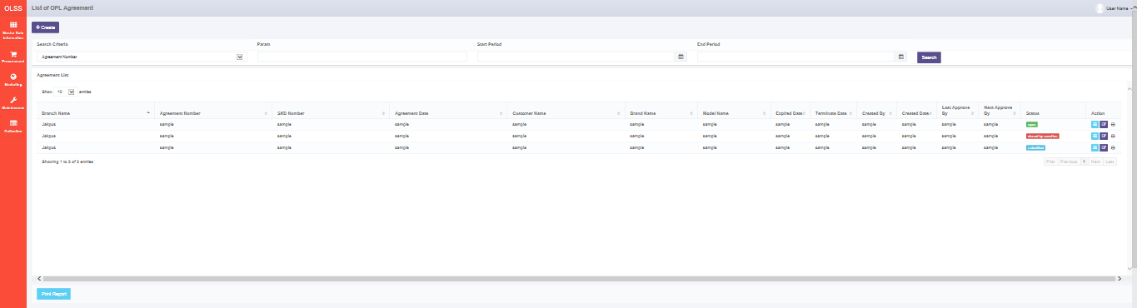



*Screen 1. List of OPL Agreement*

* *Create OPL Agreement*

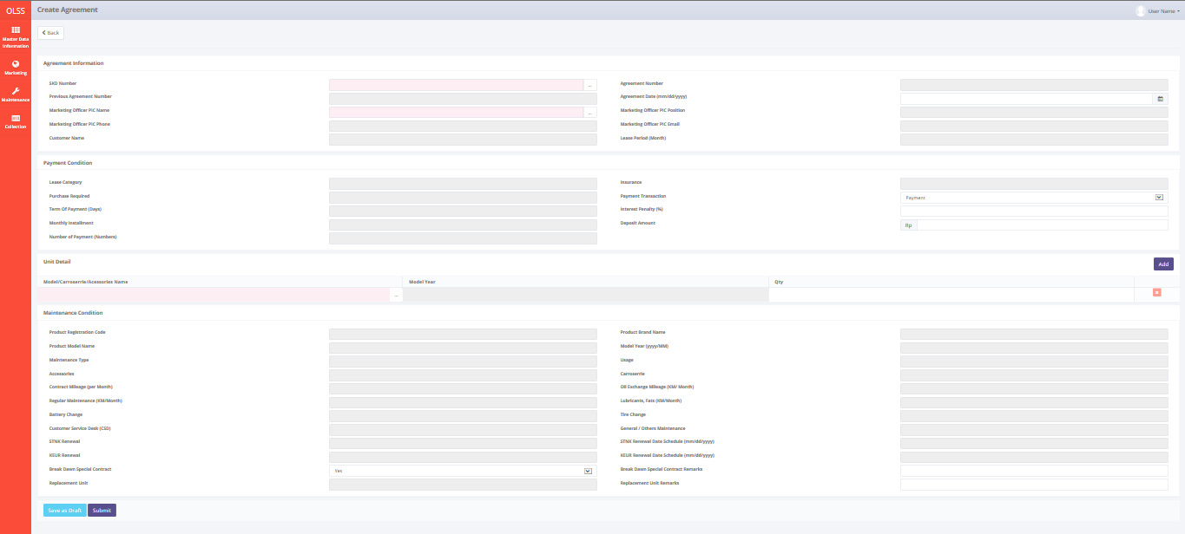

*Screen 2. Create OPL Agreement*

* *Edit OPL Agreement*

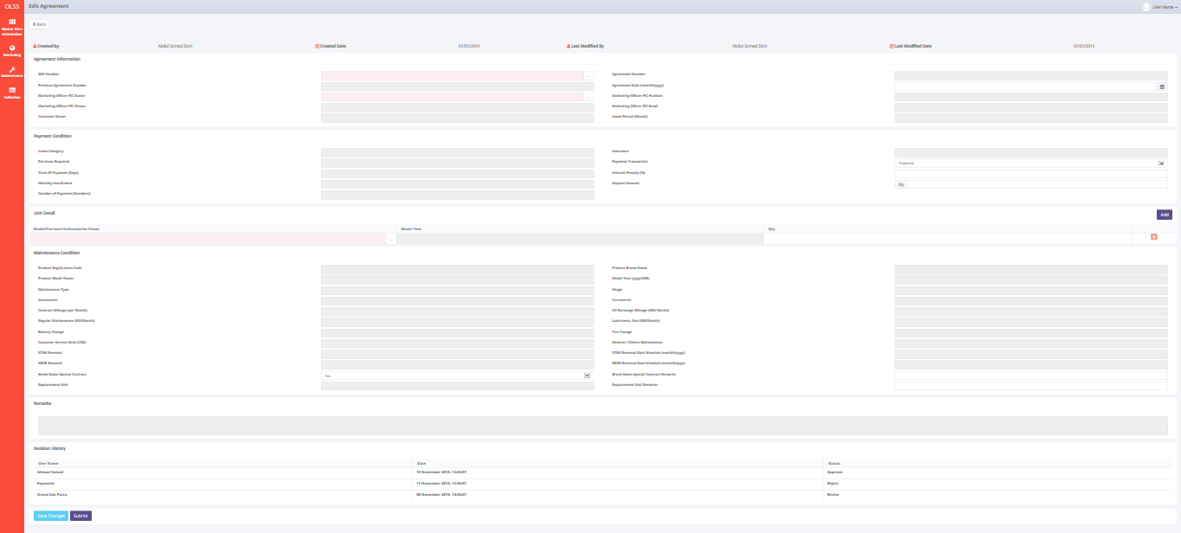

*Screen 3. Edit OPL Agreement*

* *View OPL Agreement*

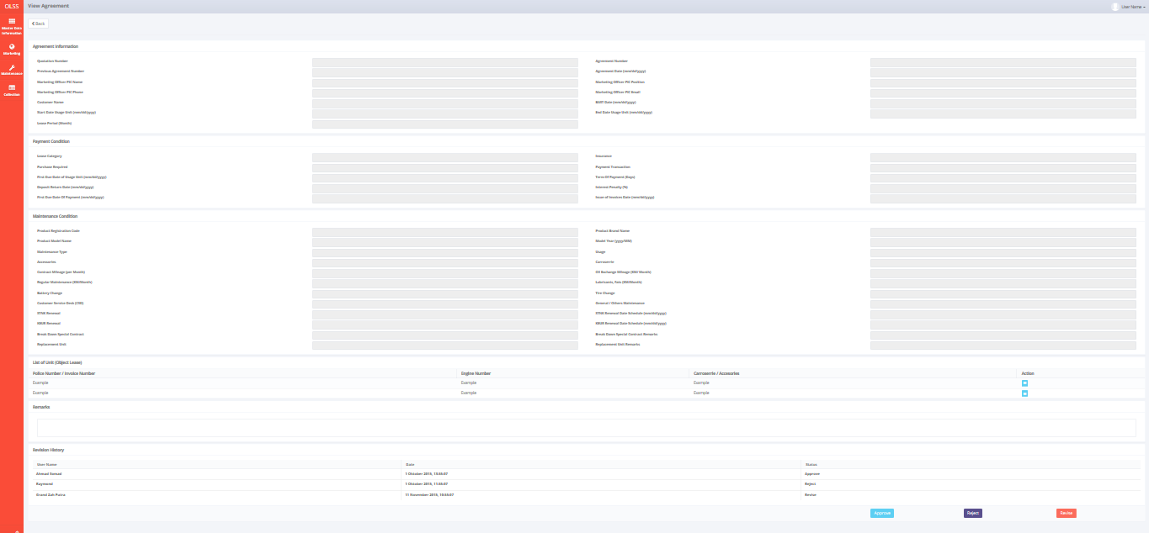

*Screen 4. View OPL Agreement*

* *Notification after Save or Submit OPL Agreement*



*Screen 5. Save or Submit Notification*

* 1. Component Screen Functionality
  2. **List of OPL Agreement**

Here are the screen functions from each component in **Screen 1. List of OPL Agreement**:

|  |  |  |  |
| --- | --- | --- | --- |
| ***No*** | ***Component*** | ***Name*** | ***Function*** |
| **Header** | | | |
| 1 | Label | List of OPL Agreement | OPL Agrement Creation title |
| 2 | Button | Create OPL Agreement | To show OPL Agreement Create screen |
| **Search Criteria** | | | |
| 3 | Drop Down Box box | Search criteria | To select the category for searching criteria |
| 4 | Text Field/ Date picker | Param | To input the value for searching criteria |
| 5 | Date picker | Start Period | To select the start date of record lists |
| 6 | Date picker | End Period | To select the end date of record lists |
| 7 | Button | Search | To do a search and showing lists according to criteria |
| **List of OPL Agreement** | | | |
| 8 | Button | Edit OPL Agreement | To show an editable screen of OPL Agreement draft which has been created |
| 9 | Button | View OPL Agreement | To show details of OPL Agreement |
| 10 | Button | Print Form OPL Agreement | To show a preview OPL Agreement report document before print |
| 11 | Drop Down Box | Entries | To show entry number of lists |
| 12 | Label | DSF Office | Display DSF Office of OPL Agreement PIC |
| 13 | Label | Agreement Number | Display Agreement number that has been created |
| 14 | Label | SKD Number | Display SKD number that OPL Agreement refer to |
| 15 | Label | Customer Name | Display Customer Name that bound to the OPL Agreement |
| 16 | Label | Model Name | Display the Model Name of Product |
| 17 | Label | Brand Name | Display the Brand Name of Product |
| 18 | Label | Expired Date | Display expire OPL Agreement Date |
| 19 | Label | Terminate Date | Display date of termination if OPL Agreement has been terminated |
| 20 | Label | End Period | Display date where OPL Agreement should be closed |
| 21 | Label | Last Approved By | Display Name of Last PIC that did approve/check the OPL Agreement record |
| 22 | Label | Next Approve By | Display Name of PIC that should approve/check the OPL Agreement record |
| 23 | Label | Created By | Display Name of PIC that created OPL Agreement record |
| 24 | Label | Created Date | Display date of OPL Agreement creation |
| 25 | Label | Status | Display Status of OPL Agreement that has been created |
| 26 | Label | Action | Display Edit, View and Form Report button |
| 27 | Label | Branch | Display Branch Name of OPL Agreement Creator |
| 28 | Label | Showing 1 to *n* of *n* entries | Display the entries generated by search engine |
| 29 | Link | First Page | To show the first page entry |
| 30 | Link | Previous Page | To show the previous page entry |
| 31 | Link | Page Number | To show the page screen according the number |
| 32 | Link | Next Page | To show the next page entry |
| 33 | Link | Last Page | To show the last page entry |
| **Footer** | | | |
| 34 | Button | Print Report | To print the report from the lists of record |

* 1. **Create OPL Agreement**

Here are the screen functions from each component in **Screen 2. Create OPL Agreement**:

|  |  |  |  |
| --- | --- | --- | --- |
| ***No*** | ***Component*** | ***Name*** | ***Function*** |
| **Header** | | | |
| 1 | Label | Create OPL Agreement | OPL Agreement Creation title |
| 2 | Button | Back | Back to previous screen |
| **Agreement Information** | | | |
| 3 | Text Field | Agreement Number | Displaying OPL Agreement Number (after save of submit) |
| 4 | Search box | SKD Number | To select the SKD that use as reference document |
| 5 | Text Field | Previous Agreement Number | Displaying pervious agreement number (for novation or rescheduled) |
| 6 | Date Picker | Agreement Date | To input Agreement Date |
| 7 | Text Field | Marketing Officer PIC Name | To input Marketing Officer PIC Name |
| 8 | Text Field | Marketing Officer PIC Position | To input Marketing Officer PIC Position |
| 9 | Text Field | Marketing Officer PIC Phone | To input Marketing Officer PIC Phone |
| 10 | Text Field | Marketing Officer PIC Email | To input Marketing Officer PIC Email |
| 11 | Text Field | Customer Name | To Display Customer Name |
| 12 | Text Field | Lease Period | To Display Lease Period (month) |
| **Payment Condition** | | | |
| 13 | Text Field | Lease Category | To Display Lease Category |
| 14 | Text Field | Insurance | To Display Insurance |
| 15 | Drop Down Box | Purhase Required | To select Purchase Required |
| 16 | Drop Down Box | Payment Transaction | To select Payment Transaction |
| 17 | Text Field | Term Of Payment (Days) | To Display TOP |
| 18 | Text Field | Interest Penalty (%) | To Input Interest Penalty |
| 19 | Text Field | Monthly Installment | Displaying Monthly Installment |
| 20 | Text Field | Deposit Amount | To Input Deposit Amount |
| 21 | Text Field | Number of Payment (Numbers) | To Display Number of payment |
| **Maintenance Condition** | | | |
| 22 | Text Field | Product Registration Code | To Display Product Registration Code |
| 23 | Text Field | Product Brand Name | To Display Product Brand Name |
| 24 | Text Field | Product Model Name | To Display Product Model Name |
| 25 | Text Field | Model Year (yyyy/MM) | To Display Product Model Year |
| 26 | Text Field | Maintenance Type | To Display Maintenance Type |
| 27 | Text Field | Usage | To Display Usage |
| 28 | Text Field | Accessories | To Display Accessories |
| 29 | Text Field | Carroserrie | To Display Carroserrie |
| 30 | Text Field | Contract Mileage (per Month) | To Display Contract Mileage |
| 31 | Text Field | Oil Exchange Mileage (KM/ Month) | To Display Oil Exchange Mileage |
| 32 | Text Field | Regular Maintenance (KM/Month) | To Display Regular Maintenance |
| 33 | Text Field | Lubricants, Fats (KM/Month) | To Display Lubricants, Fats |
| 34 | Text Field | Battery Change | To Display Battery Change |
| 35 | Text Field | Tire Change | To Display Tire Change |
| 36 | Text Field | Customer Service Desk (CSD) | To Display Customer Service Desk |
| 37 | Text Field | General / Others Maintenance | To Display General / Others Maintenance |
| 38 | Text Field | STNK Renewal | To Display STNK Renewal |
| 39 | Text Field | KEUR Renewal | To Display KEUR Renewal |
| 40 | Drop Down Box | Break Dawn Special Contract | To select Break Dawn Special Contract Remarks |
| 41 | Text Field | Break Dawn Special Contract Remarks | To Input Break Dawn Special Contract Remarks |
| 42 | Text Field | Replacement Unit | To Display Replacement Unit |
| 43 | Text Field | Replacement Unit Remarks | To Input Replacement Unit Remarks |
| **Unit Detail** | | | |
| 44 | Search box | Model/Carroserrie/Acessories Name | To Select Name of Product Model, Carroserrie, or Acessories |
| 45 | Text Field | Model Year | To Display Produc Model Year |
| 46 | Text Field | Qty | To Input quantity of unit/carroserie/accessories |
| **Footer** | | | |
| 47 | Button | Save as Draft | To save the inputted form as draft document |
| 48 | Button | Submit | To submit the inputted form |

* 1. **Edit OPL Agreement**

Here are the screen functions from each component in **Screen 3. Edit OPL Agreement :**

*See Component Screen Specification - b. Create OPL Agreement with addition of these components :*

|  |  |  |  |
| --- | --- | --- | --- |
| ***No*** | ***Component*** | ***Name*** | ***Function*** |
| **Header** | | | |
| 1 | Label | Edit OPL Agreement | Edit OPL Agreement title |
| 2 | Label | Created By | Displaying Created By |
| 3 | Label | Created Date | Displaying Created Date |
| 4 | Label | Last Modified By | Displaying Last Modified By |
| 5 | Label | Last Modified Date | Displaying Last Modified Date |
| **Revision History** | | | |
| 6 | Label | Revision History | Revision History sub-title |
| 7 | Label | User Name | Displaying User Name |
| 8 | Label | Date | Displaying Date |
| 9 | Label | Status | Displaying Status |
| **Footer** | | | |
| 10 | Button | Save Changes | To save the inputted form as draft document |

*and also this component is not available in Edit OPL Agreement :*

|  |  |  |  |
| --- | --- | --- | --- |
| ***No*** | ***Component*** | ***Name*** | ***Function*** |
| **Header** | | | |
| 1 | Label | Create OPL Agreement | Create OPL Agreement title |
| **Footer** | | | |
| 2 | Button | Save as Draft | To save the inputted form as draft document |

* 1. **View OPL Agreement**

Here are the screen functions from each component in **Screen 4. View OPL Agreement**:

*See Component Screen Specification - b. Create OPL Agreement with addition of these components :*

|  |  |  |  |
| --- | --- | --- | --- |
| ***No*** | ***Component*** | ***Name*** | ***Function*** |
| **Header** | | | |
| 1 | Label | View OPL Agreement | View OPL Agreement title |
| 2 | Label | Created By | Displaying Created By |
| 3 | Label | Created Date | Displaying Created Date |
| 4 | Label | Last Modified By | Displaying Last Modified By |
| 5 | Label | Last Modified Date | Displaying Last Modified Date |
| **Revision History** | | | |
| 6 | Label | Revision History | Revision History sub-title |
| 7 | Label | User Name | Displaying User Name |
| 8 | Label | Date | Displaying Date |
| 9 | Label | Status | Displaying Status |
| **Agreement Information** | | | |
| 10 | Text Field | BAST Date (mm/dd/yyyy) | To Display BAST Date |
| 11 | Text Field | Start Date Usage Unit (mm/dd/yyyy) | To Display Start Date Usage Unit |
| 12 | Text Field | End Date Usage Unit (mm/dd/yyyy) | To Display End Date Usage Unit |
| **List of Unit (Object Lease)** | | | |
| 13 | Label | Police Number / Invoice Number | To Display Police Number / Invoice Number |
| 14 | Label | Engine Number | To Display Engine Number |
| 15 | Label | Carroserrie / Accesories | To Display Carroserrie / Accesories |
| 16 | Button | Action | To show detail on modal dialogue |
| **Footer** | | | |
| 17 | Text Area | Remarks | To input Remarks |
| 18 | Button | Check | To Check the Agreement document |
| 19 | Button | Approve | To Approve the Agreement document |
| 20 | Button | Revise | To Revise the Agreement document |

*and also this component is not available in View OPL Agreement :*

|  |  |  |  |
| --- | --- | --- | --- |
| ***No*** | ***Component*** | ***Name*** | ***Function*** |
| **Header** | | | |
| 1 | Label | Create OPL Agreement | Create OPL agreement title |
| **Footer** | | | |
| 2 | Button | Save as Draft | To save the inputted form as draft document |
| 3 | Button | Submit | To submit the inputted form |

* 1. Operation Description

|  |  |  |
| --- | --- | --- |
| **No.** | **Operation Name** | **Description** |
| 1 | Initial view of List of Agreement | The screen for list of Agreement:   1. Component Status;  |  |  |  |  | | --- | --- | --- | --- | | Component | Name/Caption | Status | Remark | | Drop Down Box box | User Name | Active |  | | Label | List of Agreement | Not Active |  | | Drop Down Box box | Operation | Active |  | | Drop Down Box box | Search criteria category | Active |  | | Drop Down Box box | Search criteria parameter | Active |  | | Button | Create Agreement | Active |  | | Button | Edit Agreement | Active |  | | Button | View Agreement | Active |  | | Button | Print Form Agreement | Active |  | | Button | Print List Agreement | Active |  | | Drop Down Box box | Entries | Active |  | | Label | Agreement Number | Not Active |  | | Label | SKD Number | Not Active |  | | Label | Customer Name | Not Active |  | | Label | Model Name | Not Active |  | | Label | Brand Name | Not Active |  | | Label | Expired Date | Not Active |  | | Label | Terminate Date | Not Active |  | | Label | Last Approved By | Not Active |  | | Label | Next Approve By | Not Active |  | | Label | Created By | Not Active |  | | Label | Created Date | Not Active |  | | Label | Status | Not Active |  | | Button | First Page | Active | Active depending on the current entry | | Button | Previous Page | Active | Active depending on the current entry | | Link | Page Number | Active | Active depending on the current entry | | Button | Next Page | Active | Active depending on the current entry | | Button | Last Page | Active | Active depending on the current entry | |
| 2 | Searching the List of OPL Agreement | Input:   1. Select searching criteria category (search criteria), searching criteria value (param), Start Period (Agrement Date), and End Period (Agrement Date) in the Search Field   D:\Users\bsi00815\AppData\Local\Microsoft\Windows\Temporary Internet Files\Content.Word\VCS_List.png  Constraint:   1. End Period can not be less than Start Period (the End Period will be locked for the date before Start Date) 2. Start Period can not be less than End Period (the Start Period will be locked for the date after End Date) 3. Click on the Search button   D:\Users\bsi00815\AppData\Local\Microsoft\Windows\Temporary Internet Files\Content.Word\Visit Customer Survey Report.png   1. The screen will view the list of OPL Agreement according to criteria 2. Select number of show list entries: 10, 25, 50, and 100 and click the page for viewing more data.   Process:   1. After Clicking the search button, the system will get the data from OPLAgreement, TBL\_MKT\_SKD table and display the data into the List   Output:   1. Display list data of OPL Agreement |
| 3 | Initial view of Create OPL Agreement | The screen for Create OPL Agreement:   1. Status component;  |  |  |  |  | | --- | --- | --- | --- | | Component | Name/Caption | Status | Remark | | Label | Create OPL Agreement | Not Active |  | | Button | Back | Active |  | | Text Field | Agreement Number | Not Active |  | | Search Box | SKD Number | Active | Mandatory field marked as red | | Text Field | Previous Agreement Number | Not Active |  | | Date Picker | Agreement Date | Active | Mandatory field marked as red | | Search Box | Marketing Officer PIC Name | Active | Mandatory field marked as red | | Text Field | Marketing Officer PIC Position | Not Active |  | | Text Field | Marketing Officer PIC Phone | Not Active |  | | Text Field | Marketing Officer PIC Email | Not Active |  | | Text Field | Customer Name | Not Active |  | | Text Field | Lease Period | Not Active |  | | Text Field | Lease Category | Not Active |  | | Text Field | Insurance | Not Active |  | | Text Field | Purhase Required | Not Active |  | | Text Field | Payment Transaction | Not Active |  | | Text Field | Term Of Payment (Days) | Not Active |  | | Text Field | Interest Penalty (%) | Active |  | | Text Field | Monthly Installment | Not Active |  | | Text Field | Deposit Amount | Active |  | | Text Field | Number of Payment (Numbers) | Not Active |  | | Text Field | Product Registration Code | Not Active |  | | Text Field | Product Brand Name | Not Active |  | | Text Field | Product Model Name | Not Active |  | | Text Field | Model Year (yyyy/MM) | Not Active |  | | Text Field | Maintenance Type | Not Active |  | | Text Field | Usage | Not Active |  | | Text Field | Accessories | Not Active |  | | Text Field | Carroserrie | Not Active |  | | Text Field | Contract Mileage (per Month) | Not Active |  | | Text Field | Oil Exchange Mileage (KM/ Month) | Not Active |  | | Text Field | Regular Maintenance (KM/Month) | Not Active |  | | Text Field | Lubricants, Fats (KM/Month) | Not Active |  | | Text Field | Battery Change | Not Active |  | | Text Field | Tire Change | Not Active |  | | Text Field | Customer Service Desk (CSD) | Not Active |  | | Text Field | General / Others Maintenance | Not Active |  | | Text Field | STNK Renewal | Not Active |  | | Text Field | KEUR Renewal | Not Active |  | | Drop Down Box | Break Dawn Special Contract | Active |  | | Text Field | Break Dawn Special Contract Remarks | Active |  | | Text Field | Replacement Unit | Not Active |  | | Text Field | Replacement Unit Remarks | Active |  | | Search box | Model/Carroserrie/Acessories Name | Not Active |  | | Text Field | Model Year | Not Active |  | | Text Field | Qty | Active |  | | Button | Save as Draft | Active |  | | Button | Submit | Active |  | |
| 4 | Create OPL Agreement | Input:   1. Click the button Create OPL Agreement on the List of Agreement screen      1. Input/ select the following field:  * SKD * Agreement Date * Marketing Officer PIC Name * Break Dawn Special Contract * Break Dawn Special Contract Remarks * Replacement Unit Remarks   Constraint:   1. Date Picker component will initially select today’s system date 2. Every field inputted cannot exceed maximum length defined in database system 3. Add Unit List:  * Click Add button on Unit List, it will add new row on add unit list table      * Select Model/Carroserrie/Accessories from Drop Down Box inside the new row that have been added * Quantity field will be enable * Insert Quantity   Constraint & Rules:   1. Quantity on Unit Detail List cannot be bigger than quantity on skd detail list. It also count the quantity from another agreement with same skd number. 2. Qty field will be disable, until Model/Carroserrie/Accessories field being selected 3. Unit List is mandatory, Empty Unit List will cause error on validation 4. Click delete button to remove Unit List Row      1. From step 9, click on Save as Draft button to save the document in draft status   D:\Users\bsi00815\AppData\Local\Microsoft\Windows\Temporary Internet Files\Content.Word\VCS_Create.png  Constraint:   1. If clicked with any of the field still hasn’t meet the validation criteria, every notification message for validation below the field will be generated 2. From step 9, click on Submit button to submit the document for next process   D:\Users\bsi00815\AppData\Local\Microsoft\Windows\Temporary Internet Files\Content.Word\VCS_Edit.png  Constraint:   1. If clicked with any of the field still hasn’t meet the validation criteria, every notification message for validation below the field will be generated   Process:   1. Selecting SKD Number will generate Provesious Agreement Number, Customer Name, Lease Period, Lease Category, Purcahse Required, Insurance, Term Of Payment, Monthly Installment, Number Of Payment, Product Registration Code, Product Model Name, Product Brand Name, Product Model Year, Usage, Maintenance Type, Carroserrie, Accessories, Contract Millage, Oil Exchange Millage, Regular Maintenance, Lubricants, Battery Changes, Tire Changes, Customer Service Desk, General/Other Maintenance, STNK Reneewal, KEUR Reneewal, STNK Reneewal Schedule, KEUR Reneewal Schedule, BreakDawn Special Contract, Replacement Unit from OPLCalculation, OPLBasicCondition, OPLFinanceCondition, OPLMaintenanceCondition, Product. 2. Selecting Marketing Officer will generate PIC Name, PIC Phone, PIC Position, PIC Email from Tb\_OPL\_Employee   Output:   1. By clicking save as draft or submit, the inputted data will be inserted into OPL Agreement table and generate a Agreement Number. 2. List of OPL Agreement screen will be added by new data with the status “Draft” for a record that has been “Save as Draft” or “Save Changes”, status “Submit” for a record that has been “Submit” 3. The data of current User Name, last update time, and status will be recorded into OPLAgreement\_History   Constraint:   1. The output won’t be generated if there are still at least one mandatory field which hasn’t been inputted. An error message for each one of the field will be depicted in red below each of the mandatory field (notification “This field is required” for mandatory field)   Alternative:   1. From step 9, click on Back button to go back to previous menu (List OPL Agreement) |
| 5 | Initial view of Edit OPL Agreement | The screen for Edit OPL Agreement:   1. Status component;   *See Create OPL Agreement status component with addition of these components:*   |  |  |  |  | | --- | --- | --- | --- | | Component | Name/Caption | Status | Remark | | Label | Edit OPL Agreement | Not Active |  | | Label | Created By | Not Active |  | | Label | Created Date | Not Active |  | | Label | Last Modified By | Not Active |  | | Label | Last Modified Date | Not Active |  | | Label | Revision History | Not Active |  | | Label | User Name | Not Active | Displayed according to last username who updated the document | | Label | Date | Not Active | Displayed according to last datetime the last username who updated the document | | Label | Status | Not Active | Displayed according to last activity the last username who updated the document | | Button | Save Changes | Active |  | |
| 6 | Edit OPL Agreement | Input:   1. Click the button Edit OPL Agreement on the List of OPL Agreement screen   D:\Users\bsi00815\Desktop\PrintScreen\Edit button.png   1. Input/ select the following field:  * SKD * Agreement Date * Marketing Officer PIC Name * Break Dawn Special Contract * Break Dawn Special Contract Remarks * Replacement Unit Remarks   Constraint:   1. Date Picker component will initially select today’s system date 2. Every field inputted cannot exceed maximum length defined in database system 3. Add Unit List:  * Click Add button on Unit List, it will add new row on add unit list table      * Select Model/Carroserrie/Accessories from Drop Down Box inside the new row that have been added * Quantity field will be enable * Insert Quantity   Constraint & Rules:   1. Quantity on Unit Detail List cannot be bigger than quantity on skd detail list. It also count the quantity from another agreement with same skd number. 2. Qty field will be disable, until Model/Carroserrie/Accessories field being selected 3. Unit List is mandatory, Empty Unit List will cause error on validation 4. Click delete button to remove Unit List Row      1. From step 20, click on Save Changes button to save the document in draft status   D:\Users\bsi00815\AppData\Local\Microsoft\Windows\Temporary Internet Files\Content.Word\VCS_Edit.png  Constraint:   1. If clicked with any of the field still hasn’t meet the validation criteria, every notification message for validation below the field will be generated (notification “This field is required” for mandatory field) 2. From step 20, click on Submit button to submit the document for next process   D:\Users\bsi00815\AppData\Local\Microsoft\Windows\Temporary Internet Files\Content.Word\VCS_Edit.png  Constraint:   1. If clicked with any of the field still hasn’t meet the validation criteria, every notification message for validation below the field will be generated   Process:   1. Selecting SKD Number will generate Provesious Agreement Number, Customer Name, Lease Period, Lease Category, Purcahse Required, Insurance, Term Of Payment, Monthly Installment, Number Of Payment, Product Registration Code, Product Model Name, Product Brand Name, Product Model Year, Usage, Maintenance Type, Carroserrie, Accessories, Contract Millage, Oil Exchange Millage, Regular Maintenance, Lubricants, Battery Changes, Tire Changes, Customer Service Desk, General/Other Maintenance, STNK Reneewal, KEUR Reneewal, STNK Reneewal Schedule, KEUR Reneewal Schedule, BreakDawn Special Contract, Replacement Unit from OPLCalculation, OPLBasicCondition, OPLFinanceCondition, OPLMaintenanceCondition, Product 2. Selecting Marketing Officer will generate PIC Name, PIC Phone, PIC Position, PIC Email from Tb\_OPL\_Employee   Output:   1. By clicking save changes or submit, the inputted data will update the OPL Agreement table. 2. List of OPL Agreement screen will be added by new data with the status “Draft” for a record that has been “Save as Draft” or “Save Changes”, status “Submut” for a record that has been “Submit”   Constraint:   1. The output won’t be generated if there are still at least one mandatory field which hasn’t been inputted or the value inputted reached maximum length of the characters. An error message for each one of the field will be generated in red   Alternative:   1. From step 20, click on Back button to go back to previous menu (List of OPL Agreement) |
| 7 | Initial view of View OPL Agreement | The screen for View OPL Agreement:   1. Status component;   *See Create OPL Agreement status component (****all status not active****) with addition of these components:*   |  |  |  |  | | --- | --- | --- | --- | | Component | Name/Caption | Status | Remark | | Label | View OPL Agreement | Not Active |  | | Label | Created By | Not Active |  | | Label | Created Date | Not Active |  | | Label | Last Modified By | Not Active |  | | Label | Last Modified Date | Not Active |  | | Label | Revision History | Not Active |  | | Label | User Name | Not Active | Displayed according to last username who updated the document | | Label | Date | Not Active | Displayed according to last datetime the last username who updated the document | | Label | Status | Not Active | Displayed according to last activity the last username who updated the document | | Button | Check | Active |  | | Button | Approve | Active |  | | Button | Revise | Active |  | |
| 8 | View OPL Agreement | Input:   1. Click the button View OPL Agreement on the List OPL Agreement screen   D:\Users\bsi00815\AppData\Local\Microsoft\Windows\Temporary Internet Files\Content.Word\Customer_Visit_Survey_List.png  Process:   1. The data on the View screen are extracted from OPLAgreement table   Output:   1. The screen displays the Data OPL Agreement table   Altenative:   1. From step 1, click on Back button to go back to previous menu (List of OPL Agreement) |
| 9 | Print Agreement | Print List  Input:   1. Click the button Print List on the List OPL Agreement screen     Process:   1. The query data result that dislayed on the list screen will be export to excel file   Output:   1. List data on excel file.   Print Document  Input:   1. Click the button Print Agreement Document on the List OPL Agreement screen     Process:   1. By clicking print document button, user will be redirected to print preview screen. 2. The screen will displayed the print preview of the agreement document document.User can check, and export the document to excel/pdf or directly print the document     *RDLC Control on Print preview screen.*  Output:   1. OPL Agreement document 2. There is three parameters that can give you different document details: 3. Maintenance Category   - Full Maintenance  - CSD  - Non Maintenance   1. Use/Not Use Replacement Car 2. Insurance / Non Insurance   Each Parameters have their own OPL Agreement report template (Total : 12 Report Template) |
| 10 | System error message | Process:   1. Any errors outside of application validation or that which cannot be handled by application such as errors when communicating with database, bugs, overloop, etc will generate an error message “System error. Please contact your administrator” 2. A log history will be generated for any error outside of application validation (same as Phase 1). This log record can be used for IT investigation should any cases appear in the system   Output:   1. A page with system error message will appear. |
| 11 | Document Status | **Draft :**  When the Creator save/create the document by clicking “Save As Draft” button, the document status will be set to Draft  **Submitted :**  When the Creator save/create the document by clicking “Submit” button, the document status will be set to Submitted  **Checked :**  When the Checker PIC check the document by clicking “Check” button, the document status will be set to Checked  **Approved :**  When the Approver PIC approve the document by clicking “Approve” button, the document status will be set to Approved  **Reject :**  When the Checker / Approver PIC Reject the document by clickin “Reject” button, the document status will be set to Reject  **Revise :**  When the Checker / Approver PIC sent the document back to revise by the creator by clicking “Revise” button, he document status will be set to Revise  **Sign By Customer :**  When Customer sign the agreement, Marketing PIC should update the document status by click “Sign By Customer” button, the document status will be set Sign By Customer  **Open :**  The OPL Agreement Status will be set to Open when BAST Process(refer to ….) already finished  **Close Incomplete :**  When OPL Agreement period is over and still had overdue billing, the document status will be set to Close Incomplete  **Close Complete :**  When OPL Agreement period is over and there is no overdue billing already complete all payment, the document status will be set to Close Incomplete  **Close by Rescheduled Incomplete:**  When new OPL Agreement with Type ‘Reschedule’ already sign by Customer and the previous agreement which set as the reference still had overdue billing, the pervious agreement document status will be set to Close by Rescheduled Incomplete  **Close by Resceduled Complete:**  When new OPL Agreement with Type ‘Reschedule’ already sign by Customer and the previous agreement which set as the reference had no overdue billing, the pervious agreement document status will be set to Close by Rescheduled Complete  **Close by Novation Incomplete:**  When new OPL Agreement with Type ‘Novation’ already sign by Customer and the previous agreement which set as the reference still had overdue billing, the pervious agreement document status will be set to Close by Novation Incomplete  **Close by Novation Complete:**  When new OPL Agreement with Type ‘Novation’ already sign by Customer and the previous agreement which set as the reference had no overdue billing, the pervious agreement document status will be set to Close by Novation Complete  **Close by Termination Incomplete:**  When OPL Agreement has been terminate and still had overdue billing, the document status will be set to Close by Termination Incomplete  **Close by Termination Complete:**  When OPL Agreement has been terminate and there is no overdue billing, the document status will be set to Close by Termination Complete |

* 1. Data Structure

**OPLAgreement**

|  |  |  |  |  |  |  |
| --- | --- | --- | --- | --- | --- | --- |
| *Field Name* | *Data Type* | *Length* | *Source* | *Remarks* | *Nullable* | *Mandatory* |
| *IdOPLAgreement* | *Integer* | *N/A* | OPLAgreement.IdOPLAgreement | ***Primary Key*** | *NO* | *YES* |
| *IdTb\_OPL\_Employee* | *Integer* | *N/A* | OPLAgreement.Id\_Tb\_OPL\_Employee | ***Foreign Key***  *Where Tb\_OPL\_Employee.Id Tb\_OPL\_Employee* | *YES* | *NO* |
| *IdTb\_MKT\_SKD* | *Integer* | *N/A* | OPLAgreement.IdTb\_MKT\_SKD | ***Foreign Key***  *Where*  *Tb\_MKT\_SKD.IdTb\_MKT\_SKD* | *YES* | *NO* |
| *TaskId* | *Uniqueidentifier* | *N/A* | OPLAgreement.TaskId |  | *YES* | *NO* |
| CustomerCode | *Varchar* | *10* | OPLAgreement.CustomerCode |  | *NO* | *YES* |
| Prev AgreementNumber | *Varchar* | *50* | OPLAgreement.AgreementNumberReff | *From OPLCalculation.AgreenentNumberReff where OPLCalculation.IdOPLCalculation = OPLQuotation.IdOPLCalculation and OPLQuotation.IdOPLQuotation = Tb\_MKT\_SKD.IdOPLQuotation and Tb\_MKT\_SKD.IdTb\_MKT\_SKD = OPLAgreement. IdTb\_MKT\_SKD* | *YES* | *NO* |
| Agreement Number | *Varchar* | *50* | OPLAgreement.AgreementNumber |  | *NO* | *YES* |
| Agreement Date | *DateTime* | *N/A* | OPLAgreement.AgreementDate |  | *NO* | *YES* |
| Start Date Usage Unit | *DateTime* | *N/A* | OPLAgreement.StartPeriodDate |  | *NO* | *YES* |
| End Date Usage Unit | *DateTime* | *N/A* | OPLAgreement.EndPeriodDate |  | *NO* | *YES* |
| Terminate Date | *DateTime* | *N/A* | OPLAgreement.TerminateDate |  | *Yes* | *No* |
| Lease Category | *Varchar* | *100* | OPLAgreement.LeaseCategory | *From OPLCalculation.LeaseCategory where OPLCalculation.IdOPLCalculation = OPLQuotation.IdOPLCalculation and OPLQuotation.IdOPLQuotation = Tb\_MKT\_SKD.IdOPLQuotation and Tb\_MKT\_SKD.IdTb\_MKT\_SKD = OPLAgreement. IdTb\_MKT\_SKD* | *NO* | *YES* |
| Insurance | *Boolean* | *N/A* | OPLAgreement.IsInsurance | *From OPLCalculation.Insurance where OPLCalculation.IdOPLCalculation = OPLQuotation.IdOPLCalculation and OPLQuotation.IdOPLQuotation = Tb\_MKT\_SKD.IdOPLQuotation and Tb\_MKT\_SKD.IdTb\_MKT\_SKD = OPLAgreement. IdTb\_MKT\_SKD* | *NO* | *YES* |
| Purchase After Lease | *Boolean* | *N/A* | OPLAgreement.PurchaseAfterLease | *From OPLCalculation.PurchaseAfterLease where OPLCalculation.IdOPLCalculation = OPLQuotation.IdOPLCalculation and OPLQuotation.IdOPLQuotation = Tb\_MKT\_SKD.IdOPLQuotation and Tb\_MKT\_SKD.IdTb\_MKT\_SKD = OPLAgreement. IdTb\_MKT\_SKD* | *NO* | *YES* |
| Payment Transaction Type | *Varchar* | *100* | OPLAgreement.PaymentTransactionType | *From OPLCalculation.PaymentTranscationType where OPLCalculation.IdOPLCalculation = OPLQuotation.IdOPLCalculation and OPLQuotation.IdOPLQuotation = Tb\_MKT\_SKD.IdOPLQuotation and Tb\_MKT\_SKD.IdTb\_MKT\_SKD = OPLAgreement. IdTb\_MKT\_SKD* | *YES* | *NO* |
| First Due Date of Usage | *DateTime* | *N/A* | OPLAgreement.FDueDateUsage |  | *YES* | *NO* |
| First Due Date of Payment | *DateTime* | *N/A* | OPLAgreement.FDDatePayment |  | *YES* | *NO* |
| Term Payment Days | *Integer* | *N/A* | OPLAgreement.TermOfPayment | *From OPLCalculation.TermPaymentDays where OPLCalculation.IdOPLCalculation = OPLQuotation.IdOPLCalculation and OPLQuotation.IdOPLQuotation = Tb\_MKT\_SKD.IdOPLQuotation and Tb\_MKT\_SKD.IdTb\_MKT\_SKD = OPLAgreement. IdTb\_MKT\_SKD* | *YES* | *NO* |
| Interest Of Penalty | *Decimal* | *18,6* | OPLAgreement.InterestOfPenalty |  | *YES* | *NO* |
| Deposit Payment Date | *DateTime* | *N/A* | OPLAgreement.DepositPaymentDate |  | *YES* | *NO* |
| Deposit Return Date | *DateTime* | *N/A* | OPLAgreement.DepositReturnDate |  | *YES* | *NO* |
| Deposit Amount | *Decimal* | *18, 3* | OPLAgreement.DepositAmount |  | *YES* | *NO* |
| Number Of Payments | *Integer* | *N/A* | OPLAgreement.NumberOfPayments |  | *YES* | *NO* |
| Total Monthly Installment | *Decimal* | *18, 3* | OPLAgreement.TotalMonthlyInstallment |  | *NO* | *YES* |
| Total Unit Qty | *Decimal* | *18, 3* | OPLAgreement.TotalUnitQuantity |  | *NO* | *YES* |
| Remarks | *Varchar* | *200* | OPLAgreement.Remarks |  | *YES* | *NO* |
| BAST Date | *DateTime* | *N/A* | OPLAgreement.BASTDate | *Format screen “MM/dd/yyyy”* | *NO* | *YES* |
| Product Code | *Varchar* | *50* | OPLAgreement.ProductCode |  | *NO* | *YES* |
| Maintenance Type | *Varchar* | *100* | OPLAgreement.MaintenanceType | *From OPLCalculation.MaintenanceType where OPLCalculation.IdOPLCalculation = OPLQuotation.IdOPLCalculation and OPLQuotation.IdOPLQuotation = Tb\_MKT\_SKD.IdOPLQuotation and Tb\_MKT\_SKD.IdTb\_MKT\_SKD = OPLAgreement. IdTb\_MKT\_SKD* | *NO* | *YES* |
| Usage | *Varchar* | *100* | OPLAgreement.Usage | *From OPLCalculation.Usage where OPLCalculation.IdOPLCalculation = OPLQuotation.IdOPLCalculation and OPLQuotation.IdOPLQuotation = Tb\_MKT\_SKD.IdOPLQuotation and Tb\_MKT\_SKD.IdTb\_MKT\_SKD = OPLAgreement. IdTb\_MKT\_SKD* | *YES* | *NO* |
| Monthly Mileage | *Integer* | *N/A* | OPLAgreement.MonthlyMileageContract | *From OPLCalculation.MonthlyMileage where OPLCalculation.IdOPLCalculation = OPLQuotation.IdOPLCalculation and OPLQuotation.IdOPLQuotation = Tb\_MKT\_SKD.IdOPLQuotation and Tb\_MKT\_SKD.IdTb\_MKT\_SKD = OPLAgreement. IdTb\_MKT\_SKD* | *YES* | *NO* |
| Periodic Maintenance Km | *Integer* | *N/A* | OPLAgreement.RegularMaintenanceMileage | *From OPLMaintenaceCondition.PeriodicMaintenanceKm where OPLMaintenanceCondition.IdOPLCalculation = OPLQuotation.IdOPLCalculation and OPLQuotation.IdOPLQuotation = Tb\_MKT\_SKD.IdOPLQuotation and Tb\_MKT\_SKD.IdTb\_MKT\_SKD = OPLAgreement. IdTb\_MKT\_SKD* | *YES* | *NO* |
| Periodic Oil Exchange | *Integer* | *N/A* | OPLAgreement.OilExchangeMileage | *From OPLMaintenaceCondition.PeriodicOilExchange where OPLMaintenanceCondition.IdOPLCalculation = OPLQuotation.IdOPLCalculation and OPLQuotation.IdOPLQuotation = Tb\_MKT\_SKD.IdOPLQuotation and Tb\_MKT\_SKD.IdTb\_MKT\_SKD = OPLAgreement. IdTb\_MKT\_SKD* | *YES* | *NO* |
| Periodic Oil Fats | *Integer* | *N/A* | OPLAgreement.LubricantsFatMileage | *From OPLMaintenaceCondition.PeriodicOilFats where OPLMaintenanceCondition.IdOPLCalculation = OPLQuotation.IdOPLCalculation and OPLQuotation.IdOPLQuotation = Tb\_MKT\_SKD.IdOPLQuotation and Tb\_MKT\_SKD.IdTb\_MKT\_SKD = OPLAgreement. IdTb\_MKT\_SKD* | *YES* | *NO* |
| Batery Km | *Integer* | *N/A* | OPLAgreement.BateryChangeMileage | *From OPLMaintenaceCondition.BateryKm where OPLMaintenanceCondition.IdOPLCalculation = OPLQuotation.IdOPLCalculation and OPLQuotation.IdOPLQuotation = Tb\_MKT\_SKD.IdOPLQuotation and Tb\_MKT\_SKD.IdTb\_MKT\_SKD = OPLAgreement. IdTb\_MKT\_SKD* | *YES* | *NO* |
| Tire Km | *Integer* | *N/A* | OPLAgreement.TireChangeMileage | *From OPLMaintenaceCondition.TireKm where OPLMaintenanceCondition.IdOPLCalculation = OPLQuotation.IdOPLCalculation and OPLQuotation.IdOPLQuotation = Tb\_MKT\_SKD.IdOPLQuotation and Tb\_MKT\_SKD.IdTb\_MKT\_SKD = OPLAgreement. IdTb\_MKT\_SKD* | *YES* | *NO* |
| CSD | *Varchar* | *100* | OPLAgreement.CSDMaintenance | *From OPLMaintenaceCondition.CSD where OPLMaintenanceCondition.IdOPLCalculation = OPLQuotation.IdOPLCalculation and OPLQuotation.IdOPLQuotation = Tb\_MKT\_SKD.IdOPLQuotation and Tb\_MKT\_SKD.IdTb\_MKT\_SKD = OPLAgreement. IdTb\_MKT\_SKD* | *YES* | *NO* |
| General Failure Maintenance | *Boolean* | *N/A* | OPLAgreement.GeneralFailureMaintenance | *General / Others Maintenance, the value will be set to ‘1’ if there is any value on OPLMaintenanceCondition. OPLMaintenanceCondition.MaintenanceOther1/ OPLMaintenanceCondition.MaintenanceOther2/ OPLMaintenanceCondition.MaintenanceOther3 where OPLMaintenanceCondition.IdOPLCalculation = OPLQuotation.IdOPLCalculation and OPLQuotation.IdOPLQuotation = Tb\_MKT\_SKD.IdOPLQuotation and Tb\_MKT\_SKD.IdTb\_MKT\_SKD = OPLAgreement. IdTb\_MKT\_SKD . Otherwise it will be set to ‘0’* | *YES* | *NO* |
| STNK Renewal | *Boolean* | *N/A* | OPLAgreement.STNKRenewal | *STNK Renewal, the value will be set to ‘1’ if there is any value on OPLFinanceCondition.STNKRenewalFee where OPLFinanceCondition.IdOPLCalculation = OPLQuotation.IdOPLCalculation and OPLQuotation.IdOPLQuotation = Tb\_MKT\_SKD.IdOPLQuotation and Tb\_MKT\_SKD.IdTb\_MKT\_SKD = OPLAgreement. IdTb\_MKT\_SKD .Otherwise it will be set to ‘0’* | *NO* | *YES* |
| STNK Renewal Date Schedule | *DateTime* | *N/A* | OPLAgreement.STNKRenewalDate |  | *YES* | *NO* |
| KEUR Renewal | *Boolean* | *N/A* | OPLAgreement.KEURRenewal | *KEUR Renewal, the value will be set to ‘1’ if there is any value on OPLFinanceCondition.KEURRenewalFee where OPLFinanceCondition.IdOPLCalculation = OPLQuotation.IdOPLCalculation and OPLQuotation.IdOPLQuotation = Tb\_MKT\_SKD.IdOPLQuotation and Tb\_MKT\_SKD.IdTb\_MKT\_SKD = OPLAgreement. IdTb\_MKT\_SKD .Otherwise it will be set to ‘0’* | *NO* | *YES* |
| KEUR Renewal Date Schedule | *DateTime* | *N/A* | OPLAgreement.KEURRenewalDate |  | *YES* | *NO* |
| Break Dawn Contract | *Boolean* | *N/A* | OPLAgreement.BreakDawnContract |  | *YES* | *NO* |
| Break Dawn Remarks | *Varchar* | *200* | OPLAgreement.BreakDawnRemarks |  | *YES* | *NO* |
| Replacement Unit | *Boolean* |  | OPLAgreement.ReplacementUnit | *Replacement Unit, the value will be set to ‘1’ if there is any value on OPLFinanceCondition.ReplacementCarAmount where OPLFinanceCondition.IdOPLCalculation = OPLQuotation.IdOPLCalculation and OPLQuotation.IdOPLQuotation = Tb\_MKT\_SKD.IdOPLQuotation and Tb\_MKT\_SKD.IdTb\_MKT\_SKD = OPLAgreement. IdTb\_MKT\_SKD .Otherwise it will be set to ‘0’* | *YES* | *NO* |
| Replacement Unit Remarks | *Varchar* | *200* | OPLAgreement.ReplacementUnitRemarks |  | *YES* | *NO* |
| Monthly Installment Amount | *Decimal* | *18,3* | OPLAgreement.MonthlyInstallmentAmount | *From OPLCalculation.MonthlyInstallmentAmount where OPLCalculation.IdOPLCalculation = OPLQuotation.IdOPLCalculation and OPLQuotation.IdOPLQuotation = Tb\_MKT\_SKD.IdOPLQuotation and Tb\_MKT\_SKD.IdTb\_MKT\_SKD = OPLAgreement. IdTb\_MKT\_SKD* | *YES* | *NO* |
| Delivery Unit Location | *Varchar* | *Max* | OPLAgreement.DeliveryUnitLocation |  | *NO* | *YES* |
| Return Unit Location | *Varchar* | *Max* | OPLAgreement.ReturnUnitLocation |  | *NO* | *YES* |
| Notes | *Varchar* | *100* | OPLAgreement.Notes |  | *YES* | *NO* |
| *IsDelete* | *Boolean* | *N/A* | OPLAgreement.IsDelete |  | *NO* | *YES* |
| *RemarksSys* | *Varchar* | *100* | OPLAgreement.RemarksSys |  | *NO* | *YES* |
| *IdTb\_OPL\_Status* | *Integer* | *N/A* | OPLAgreement.IdTb\_OPL\_Status |  | *YES* | *NO* |
| CreatedDate | *DateTime* | *N/A* | OPLAgreement.CreatedDate |  | *NO* | *YES* |
| CreatedBy | *Varchar* | *50* | OPLAgreement.CreatedBy |  | *NO* | *YES* |
| LastModified | *DateTime* | *N/A* | OPLAgreement.LastModified |  | *YES* | *NO* |
| LastModifiedBy | *Varchar* | *50* | OPLAgreement.LastModifiedBy |  | *YES* | *NO* |

**OPLAgreementDetails**

|  |  |  |  |  |  |  |
| --- | --- | --- | --- | --- | --- | --- |
| *Field Name* | *Data Type* | *Length* | *Source* | *Remarks* | *Nullable* | *Mandatory* |
| *IdOPLAgreementDetails* | *Integer* | *N/A* | OPLAgreementDetails.IdOPLAgreementDetails | ***Primary Key*** | *NO* | *YES* |
| *IdOPLAgreement* | *Integer* | *N/A* | OPLAgreementDetails.IdOPLAgreement | ***Foreign Key,*** *has relation with OPLAgreement.IdOPLAgreement* | *NO* | *YES* |
| *IdTb\_MKT\_SKD\_Dtl* | *Integer* | *N/A* | OPLAgreementDetails.IdTb\_MKT\_SKD\_Dtl | ***Foreign Key,*** *has relation with Tb\_MKT\_SKD\_Dtl.IdTb\_MKT\_SKD\_Dtl* | *YES* | *NO* |
| *IdProduct* | *Integer* | *N/A* | OPLAgreementDetails.IdProduct | ***Foreign Key****, has relation with Product.IdProduct* | *NO* | *YES* |
| Name | *Integer* | *N/A* | OPLAgreementDetails.Name | *From Tb\_MKT\_SKD\_Dtl.Name where OPLAgreementDetails.IdTb\_MKT\_SKD\_Dtl = Tb\_MKT\_SKD\_Dtl. IdTb\_MKT\_SKD\_Dtl* | *YES* | *NO* |
| Type | *Integer* | *N/A* | OPLAgreementDetails.Type | *From Tb\_MKT\_SKD\_Dtl.Type where OPLAgreementDetails.IdTb\_MKT\_SKD\_Dtl = Tb\_MKT\_SKD\_Dtl. IdTb\_MKT\_SKD\_Dtl* | *YES* | *NO* |
| *IdSupplier* | *Integer* | *N/A* | OPLAgreementDetails.IdSupplier | ***Foreign Key****, has relation with Supplier.IdSupplier* | *NO* | *YES* |
| Qty | *Integer* | *N/A* | OPLAgreementDetails.Qty |  | *NO* | *YES* |
| *IsDelete* | *Boolean* | *N/A* | OPLAgreement.IsDelete |  | *NO* | *YES* |
| *RemarksSys* | *Varchar* | *100* | OPLAgreement.RemarksSys |  | *NO* | *YES* |
| *CreatedDate* | *DateTime* | *N/A* | OPLAgreementDetails.CreatedDate |  | *NO* | *YES* |
| *CreatedBy* | *Varchar* | *50* | OPLAgreementDetails.CreatedBy |  | *NO* | *YES* |
| *LastModifiedDate* | *DateTime* | *N/A* | OPLAgreementDetails.LastModifiedDate |  | *YES* | *NO* |
| *LastModifiedBy* | *Varchar* | *50* | OPLAgreementDetails.LastModifiedBy |  | *YES* | *NO* |

**OPLUObjectLease**

|  |  |  |  |  |  |  |
| --- | --- | --- | --- | --- | --- | --- |
| *Field Name* | *Data Type* | *Length* | *Source* | *Remarks* | *Nullable* | *Mandatory* |
| *IdUObjectLease* | *Integer* | *N/A* | OPLUObjectLease.IdUObjectLease | ***Primary Key*** | *NO* | *YES* |
| *IdOPLAgreement* | *Integer* | *N/A* | OPLUObjectLease.IdOPLAgreement | ***Foreign Key****, has relation with OPLAgreement.IdOPLAgreement* | *NO* | *YES* |
| *IdUnit* | *Integer* | *N/A* | OPLUObjectLease.IdUnit | ***Foreign Key****, has relation with Tb\_OPL\_Unit.IdTb\_OPL\_Unit* | *NO* | *YES* |
| Carroserie/Accessories | *Varchar* | *Max* | OPLUObjectLease.CarroAcce |  | *YES* | *NO* |
| IsDelete | *Boolean* | *N/A* | OPLAgreement.IsDelete |  | *NO* | *YES* |
| RemarksSys | *Varchar* | *100* | OPLAgreement.RemarksSys |  | *NO* | *YES* |
| CreatedDate | *DateTime* | *N/A* | OPLAgreementDetails.CreatedDate |  | *NO* | *YES* |
| CreatedBy | *Varchar* | *50* | OPLAgreementDetails.CreatedBy |  | *NO* | *YES* |
| LastModifiedDate | *DateTime* | *N/A* | OPLAgreementDetails.LastModifiedDate |  | *YES* | *NO* |
| LastModifiedBy | *Varchar* | *50* | OPLAgreementDetails.LastModifiedBy |  | *YES* | *NO* |

* 1. Screen Item List
     1. **Print List**

|  |  |  |  |  |
| --- | --- | --- | --- | --- |
| *No.* | *Content* | *Description* | *Source* | *Remarks* |
| 1 | Agreement Report | Default Label | Static |  |
| 2 | Period | Period Monthly Report | Based on selected Start Date and End Date that already select by User when print Report | *Format display on report: MM/dd/yyyy* |
| 3 | Page | Number of Report Page | Automatically count by number of page | *&[page] of &[total page]* |
| 4 | Printed By | Printed by | User.UserName | User Name is the one who login to system |
| 5 | Printed Date | Printed Date | Use date at server when button Print Report is clicked | *Format display on report: MM/dd/yyyy* |
| 6 | DSF Office | Branch Short Name | Tb\_MGT\_UnitPreparation.DSFOffice |  |
| 7 | Agreement No | Agreement number | OPLAgreement.Agreement |  |
| 8 | SKD No | SKD Number | OPLAgreement.SKDNo |  |
| 9 | Customer Name | Customer Name | Customer.CustomerName |  |
| 10 | Brand Name | Product Brand Name | Product.BrandName |  |
| 11 | Model Name | Product Model Name | Product.Model.Name |  |
| 12 | BAST Date | BAST Date | OPLAgreement.BASTDate | *Format display on report: MM/dd/yyyy* |
| 13 | Expired Date | Expired Date | OPLAgreement. Expired Date | *Format display on report: MM/dd/yyyy* |
| 14 | Terminate Date | Termination Date | OPLAgreement.Terminate Date | *Format display on report: MM/dd/yyyy* |
| 15 | Status | Status of OPL Agreement | OPLAgreement.Status |  |

**Note:**

Content number 1,2,3,4,5, and Header of table will be repeatedly print on each page

**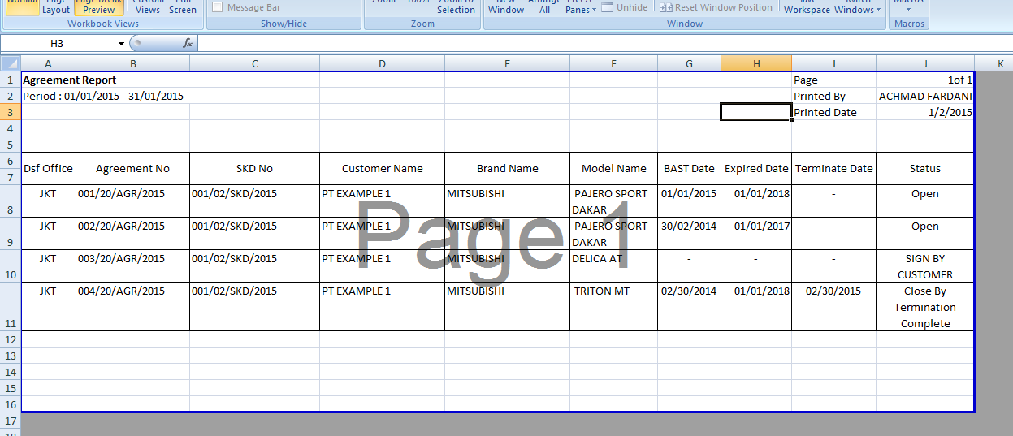**

15

14

13

12

11

10

6

7

8

9

5

4

3

2

1

* + 1. **Print Document**

|  |  |  |  |  |
| --- | --- | --- | --- | --- |
| *No.* | *Content* | *Description* | *Source* | *Remarks* |
| 1 | Agreement No | Agreement number | OPLAgreement.Agreement |  |
| 2 | Agreement Date | Agreement Date | OPLAgreement.AgreementDate | *Format display on report: Day, {tanggal} dd/M/yyyy* |
| 3 | Customer Name | Customer Name | Customer.CustomerName |  |
| 4 | Customer Address | Customer Adress | Customer.Adress |  |
| 5 | Representative Name | Customer Representative Director Name | Customer.RepresentativeDirectorName |  |
| 6 | Customer Name | Customer Name | Customer.CustomerName |  |
| 7 | PIC Name | PIC NAme | Employee.EmployeeName |  |
| 8 | Customer Name | Customer Name | Customer.CustomerName |  |
| 9 | Customer Address | Customer Adress | Customer.Adress |  |
| 10 | Customer Telephone | Customer Telephone Number | Customer.Telephone |  |
| 11 | Agreement Number | Agreement Number | OPLAgreement.AgreementNumber |  |
| 12 | Qty | Unit Qty | OPLAgreement.TotalUnitQty |  |
| 13 | Model Name | Model Name | Product.ModelName |  |
| 14 | Customer Name | Customer Name | Customer.CustomerName |  |
| 15 | Delivery Unit Location | Delivery Unit Location | OPLAgreement.DeliveryUnitLocation |  |
| 16 | Customer Name | Customer Name | Customer.CustomerName |  |
| 17 | Return Unit Location | Return Unit Location | OPLAgreement.ReturnUnitLocation |  |
| 18 | Lease Period | Lease Period | OPLCalculation.LeasePeriodPlan |  |
| 19 | Qty | Unit Qty | OPLAgreement.TotalUnitQty |  |
| 20 | Brand Name | Product Brand Name | Product.Brand Name |  |
| 21 | Model Name | Product Model Name | Product.ModelName |  |
| 22 | Carroserrie | Carroserrie | OPLUObjecLease.Carroserrie |  |
| 23 | Accessories | Accessories | OPLUObjectLease.Accessories |  |
| 24 | Qty | Unit Qty | OPLAgreement.TotalUnitQty |  |
| 25 | Monthly Installment | Monthly Installment | OPLAgrement.MonthlyInstallmentAmont |  |
| 26 | Total Monthly Installment | Total Monthly Installment | OPLAgreement.TotalMonthlyInstallment |  |
| 27 | Insurance Condition | Show Insurance Condition (if using Insurance) | OPLInsuranceCondition |  |
| 28 | Insurace Condition Amount | Insurance Condition Amount | OPLInsuranceCondition.ComperhensiveRate\*(following the name of insurance coverage) |  |
| 29 | Term of Payment | Term of Payment | OPLAgreement.TermOfPayment |  |
| 30 | Agreement No | Agreement number | OPLAgreement.Agreement |  |
| 31 | Agreement Date | Agreement Date | OPLAgreement.AgreementDate | *Format display on report: Day, {tanggal} dd/M/yyyy* |
| 32 | Customer Name | Customer Name | Customer.CustomerName |  |
| 33 | Model Name | Product Model Name | Product.ModelName |  |
| 34 | ChasisNumber | Unit Chasis Number | Unit.ChasisNumber |  |
| 35 | Engine Number | Unit Engine Number | Unit.EngineNumber |  |
| 36 | Carroserrie | Carroserrie | OPLUObjecLease.Carroserrie |  |
| 37 | Accessories | Accessories | OPLUObjectLease.Accessories |  |
| 38 | Agreement No | Agreement number | OPLAgreement.Agreement |  |
| 39 | Agreement Date | Agreement Date | OPLAgreement.AgreementDate | *Format display on report: Day, {tanggal} dd/M/yyyy* |
| 40 | Customer Name | Customer Name | Customer.CustomerName |  |
| 41 | Lease Period | Lease Period | OPLCalculation.LeasePeriodPlan |  |
| 42 | Term of Payment | Term of Payment | OPLAgreement.TermOfPayment |  |
| 43 | Penalty rate | Penalty rate | OPLAgreement.InsterestOfPenalty |  |
| 44 | Time span (days) | Term of Payment + 1 | OPLAgreement.TermOfPayment |  |

**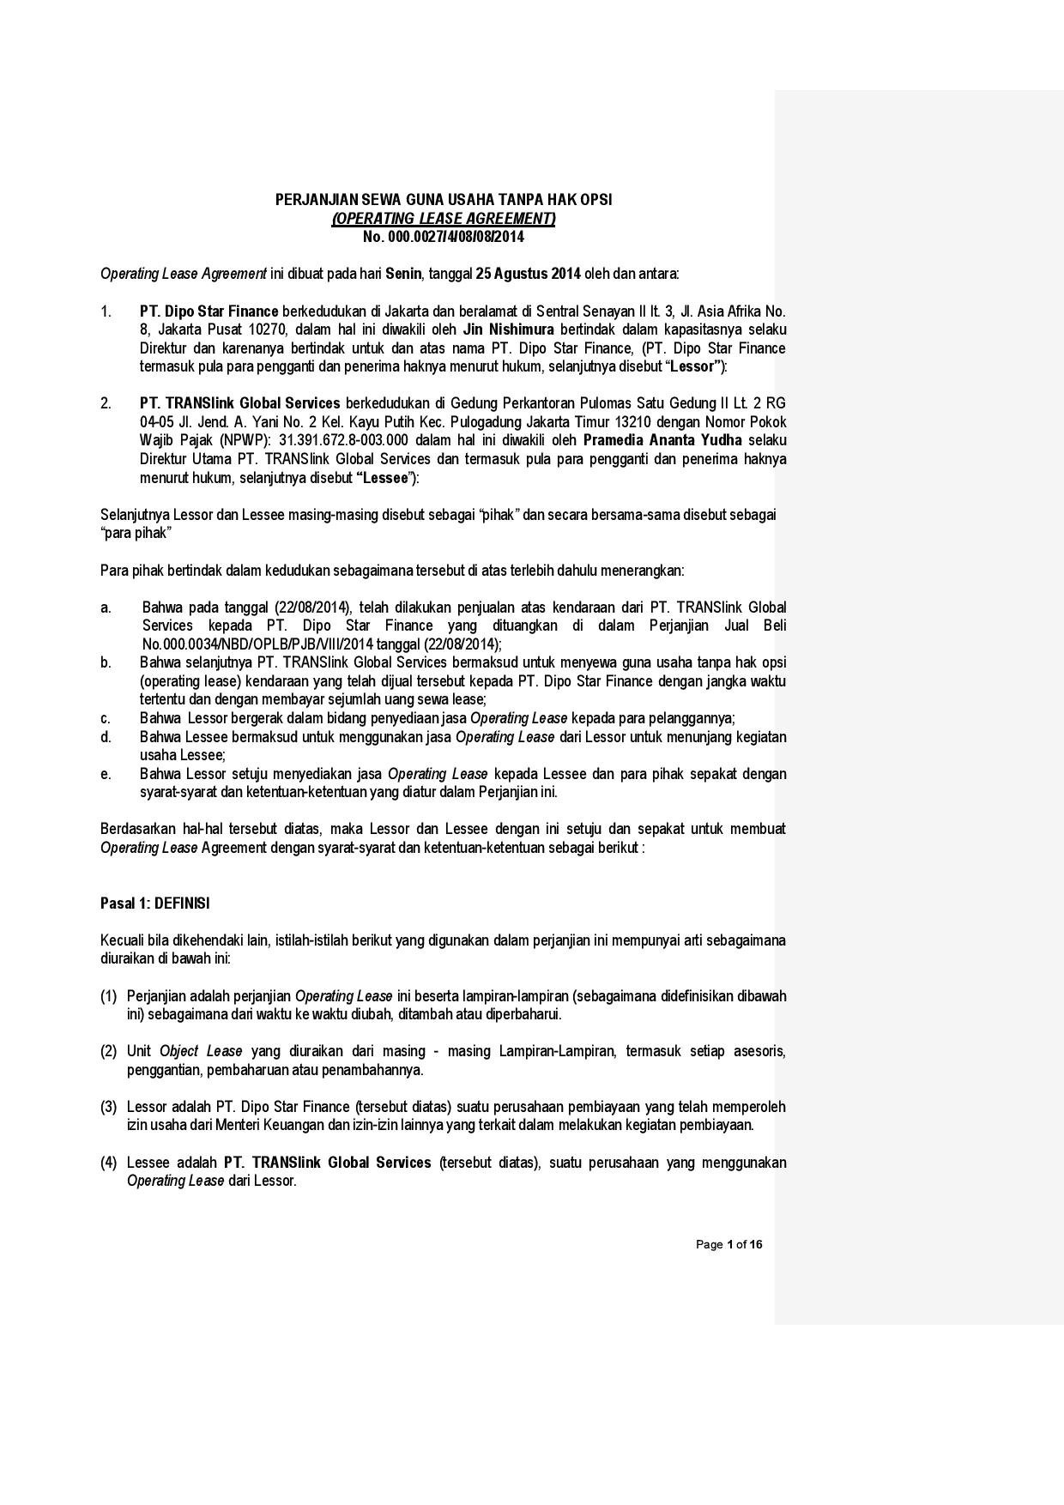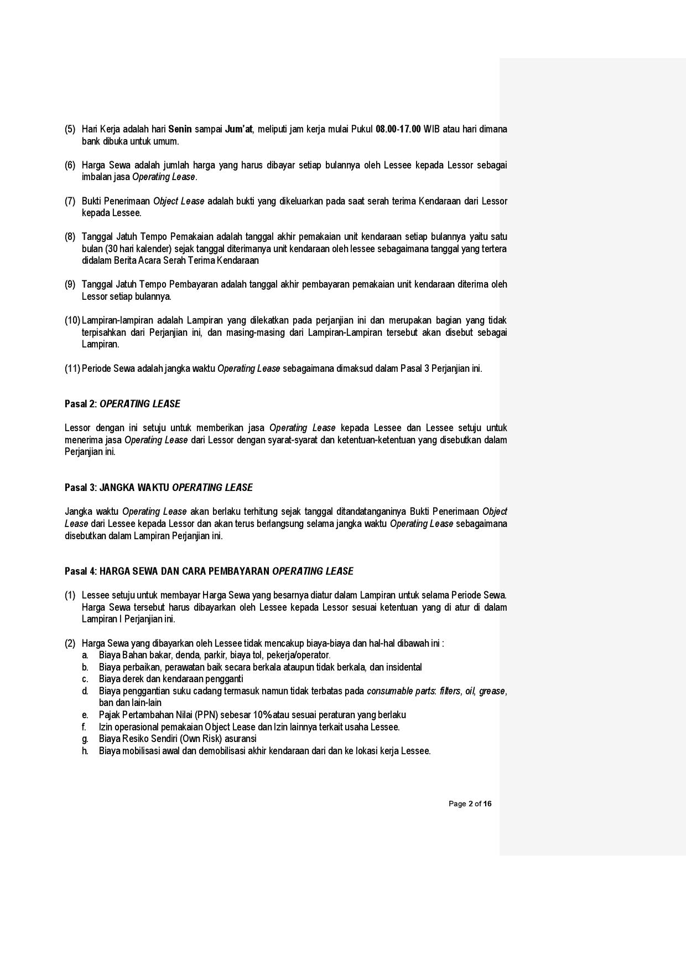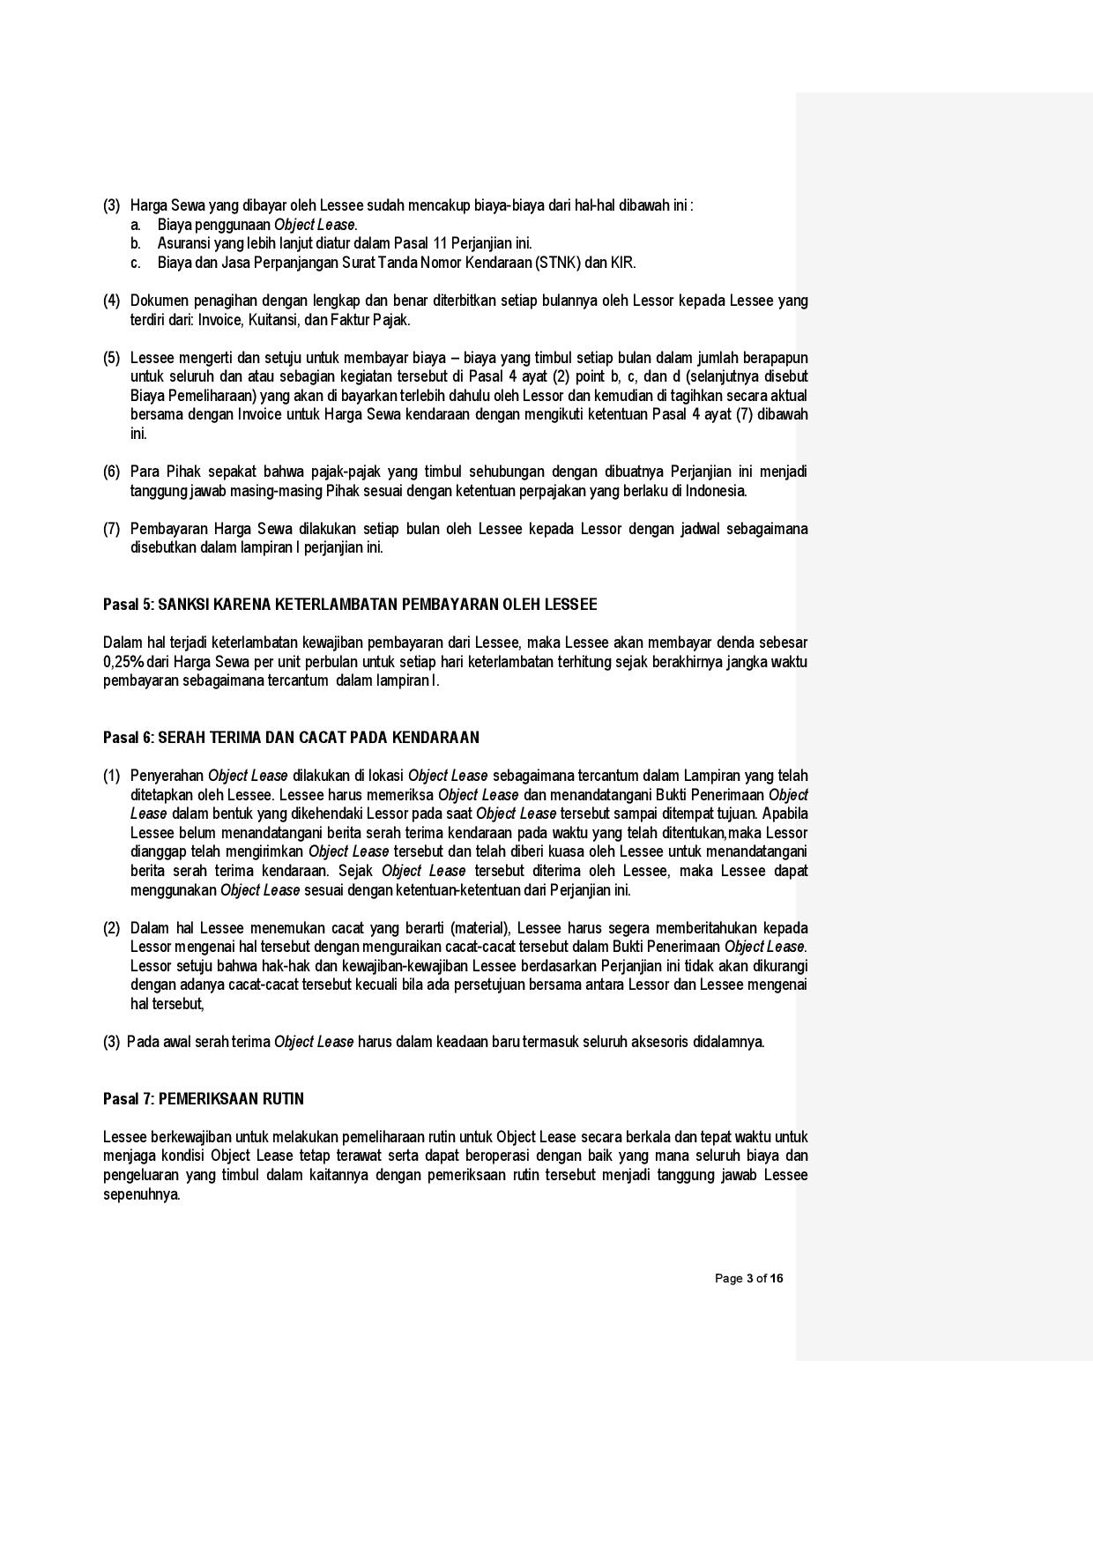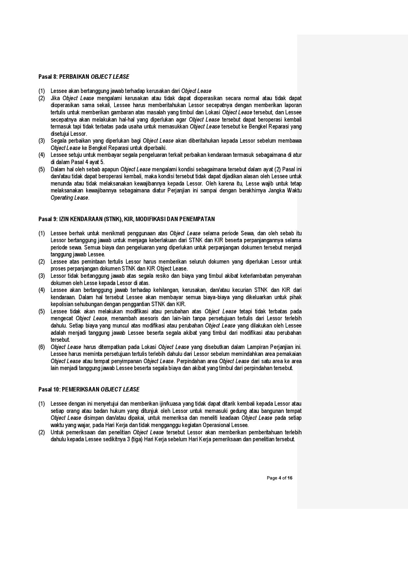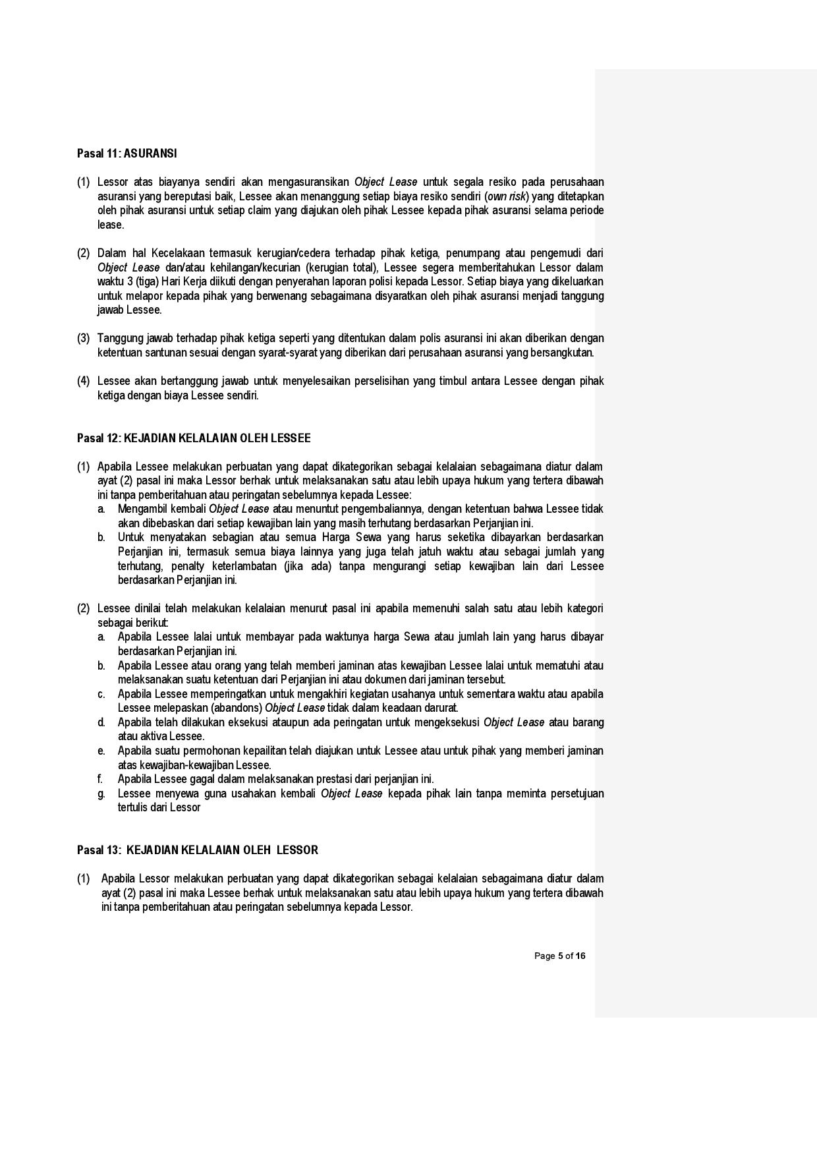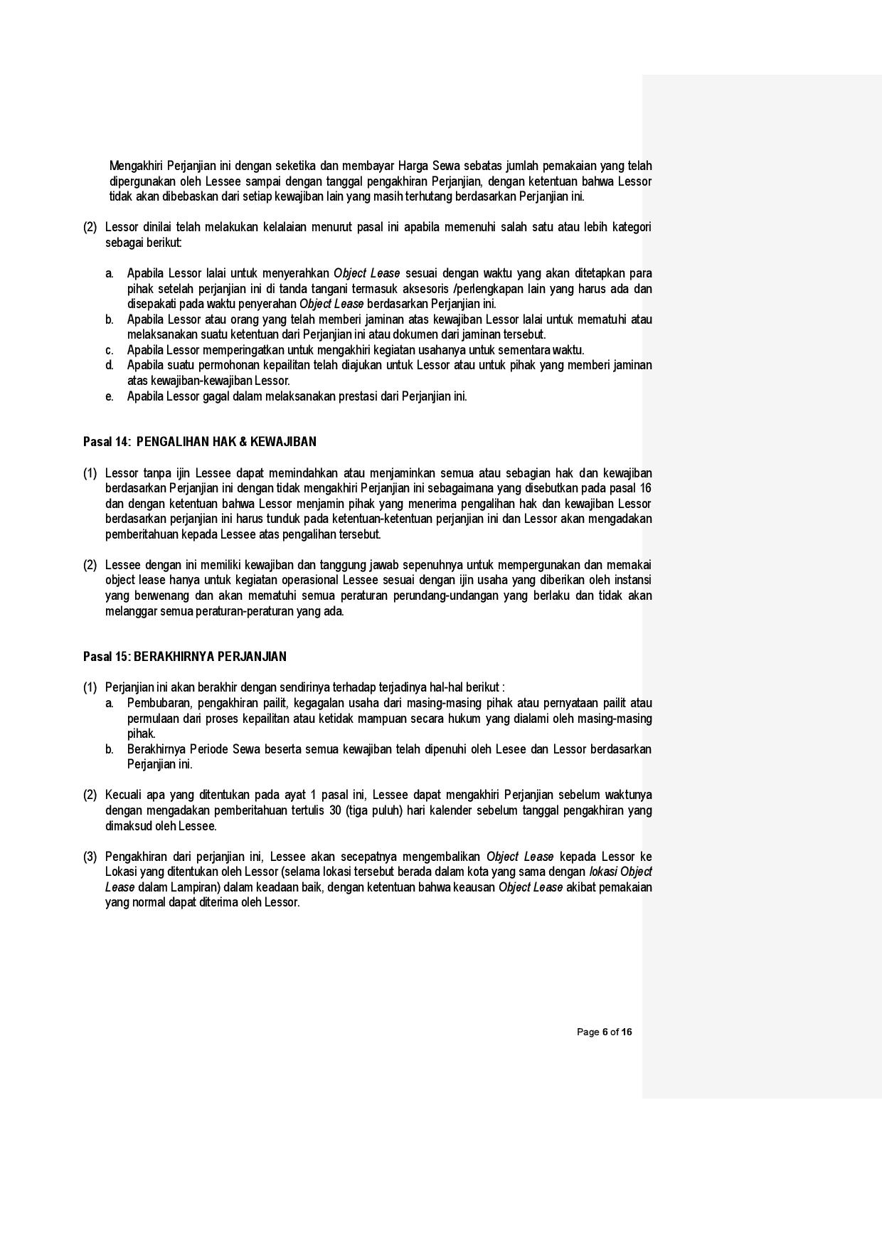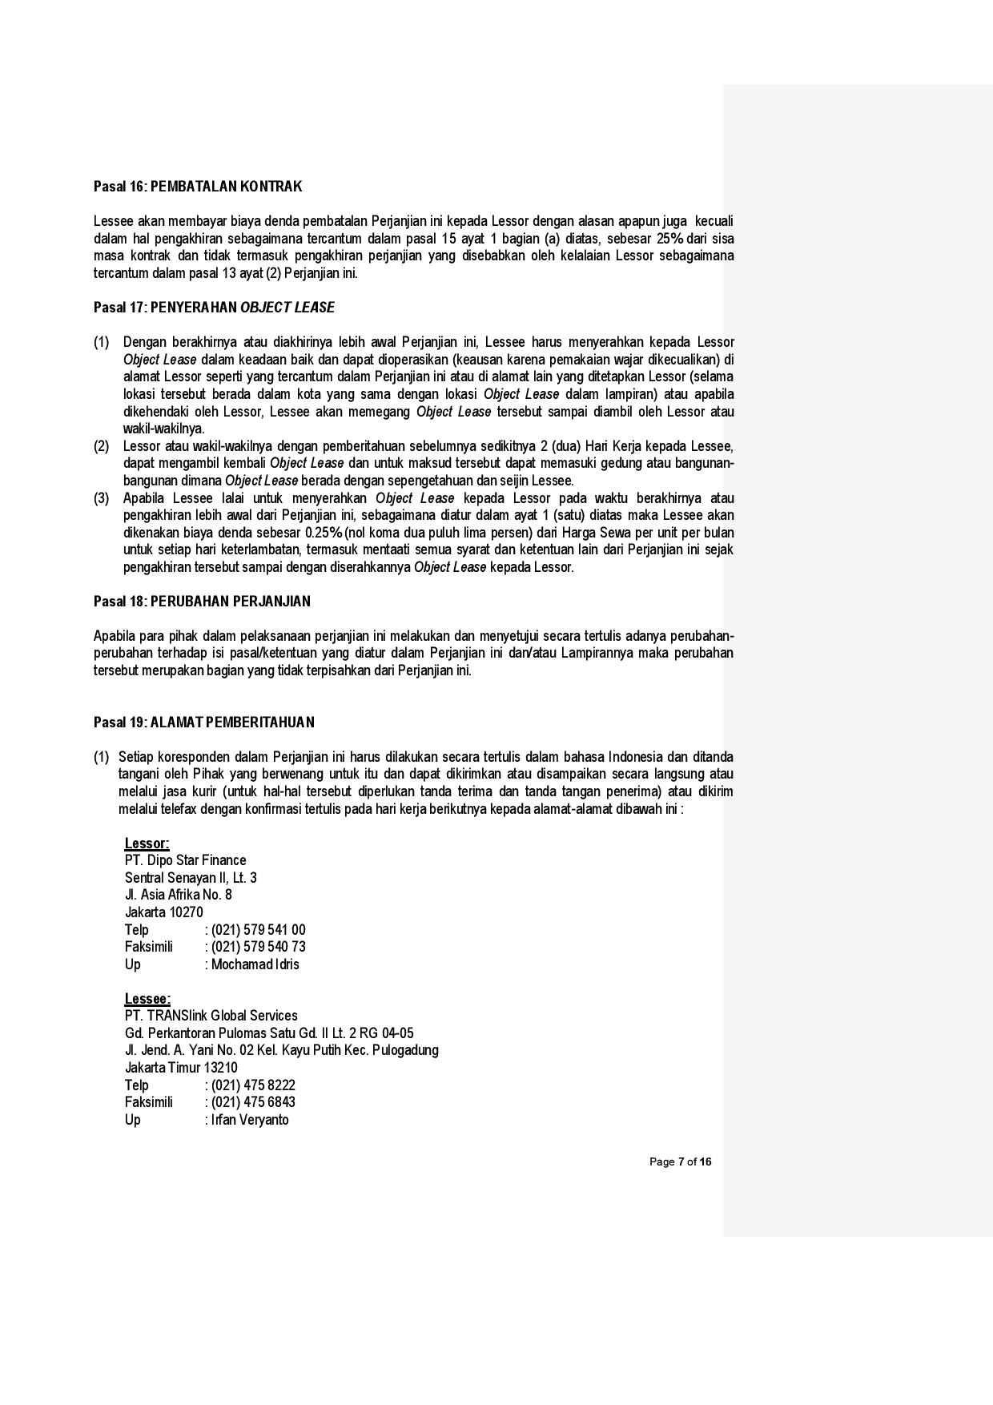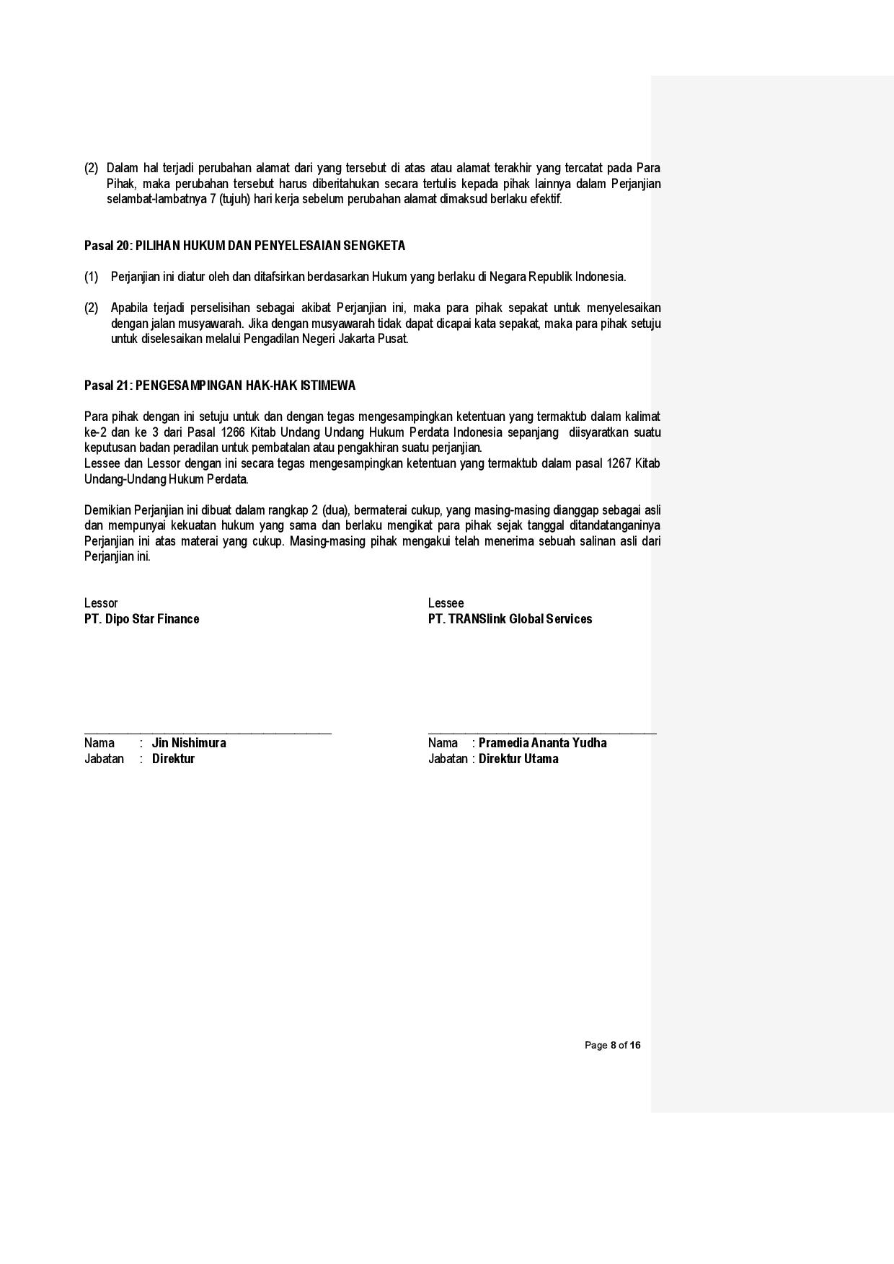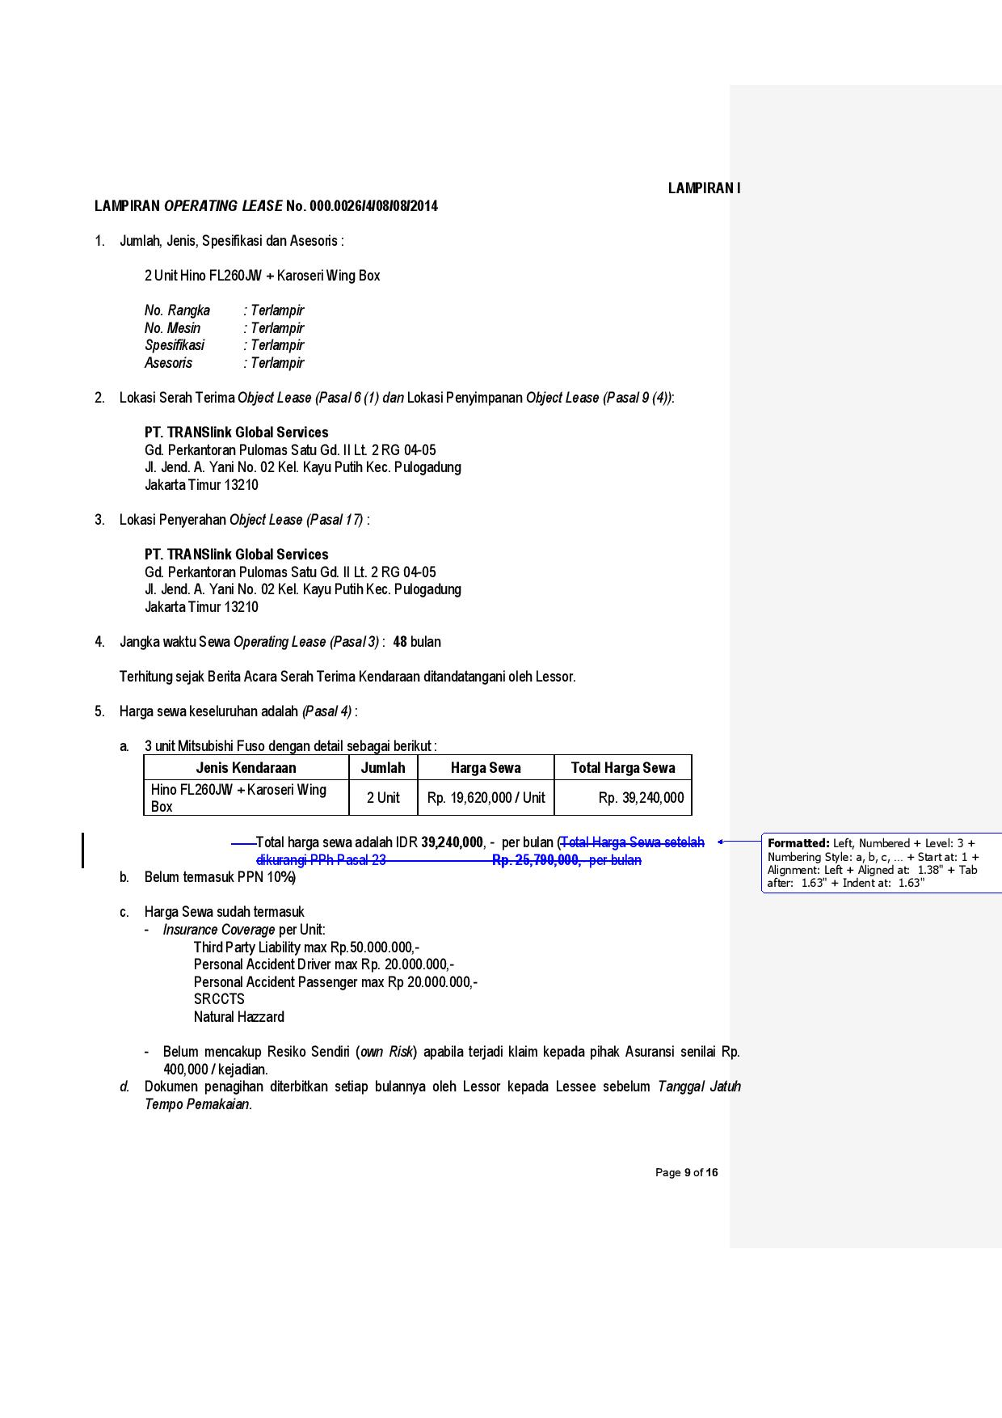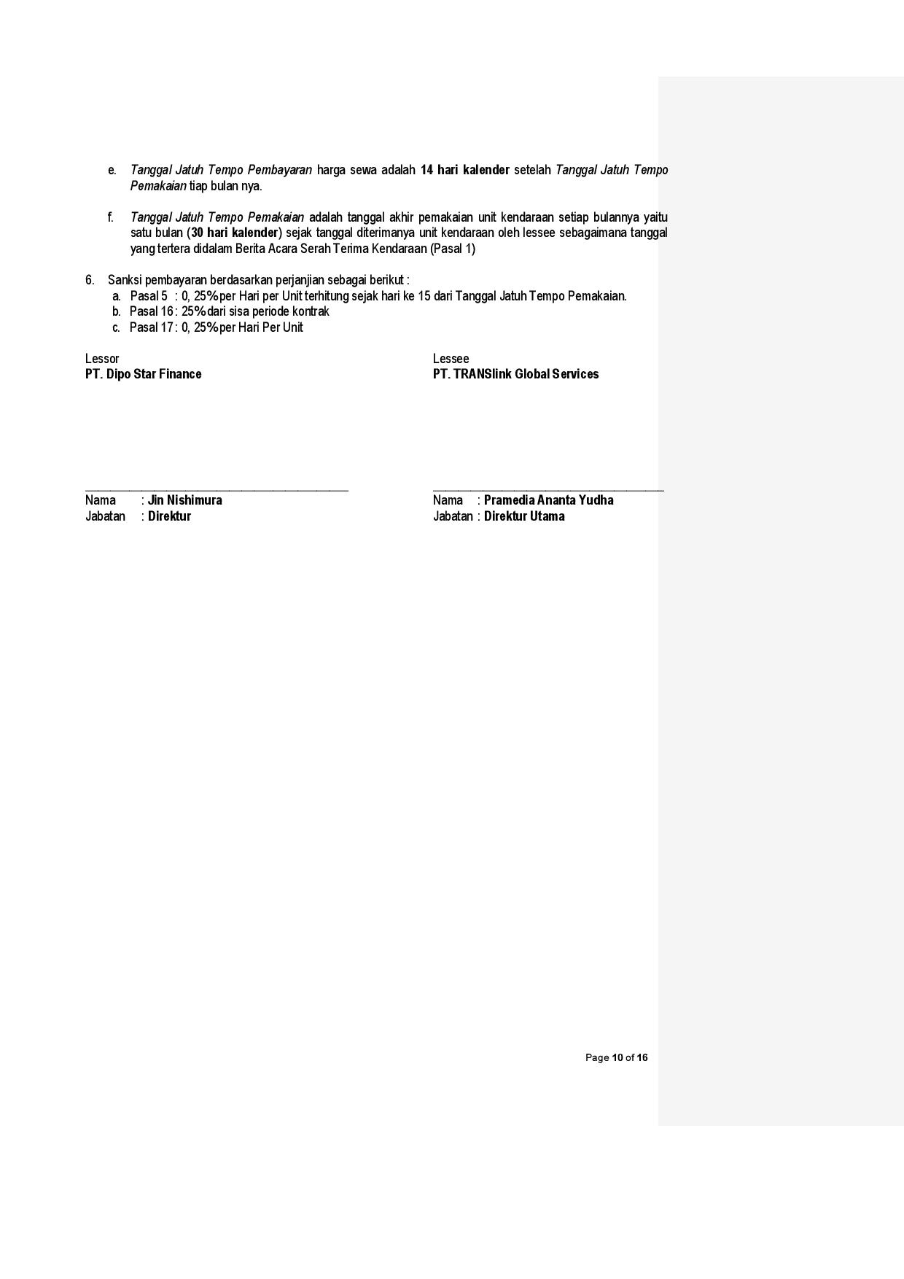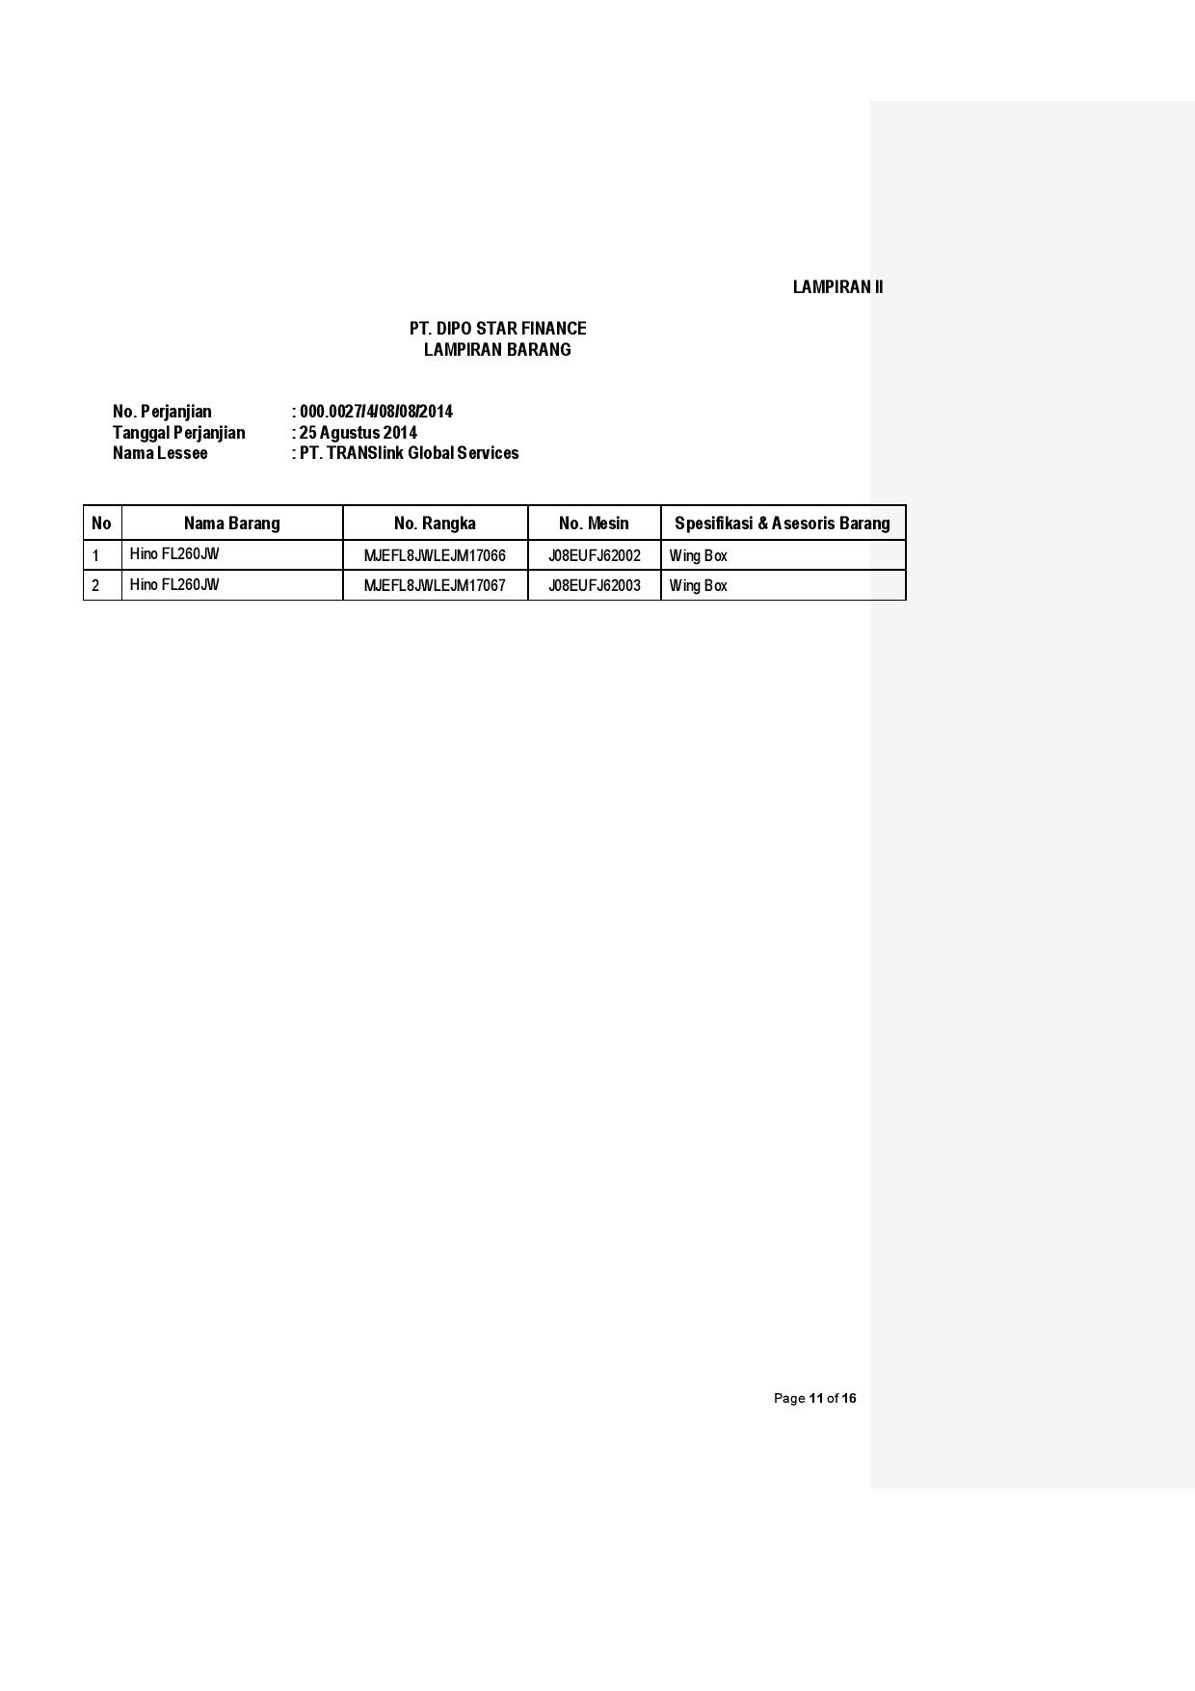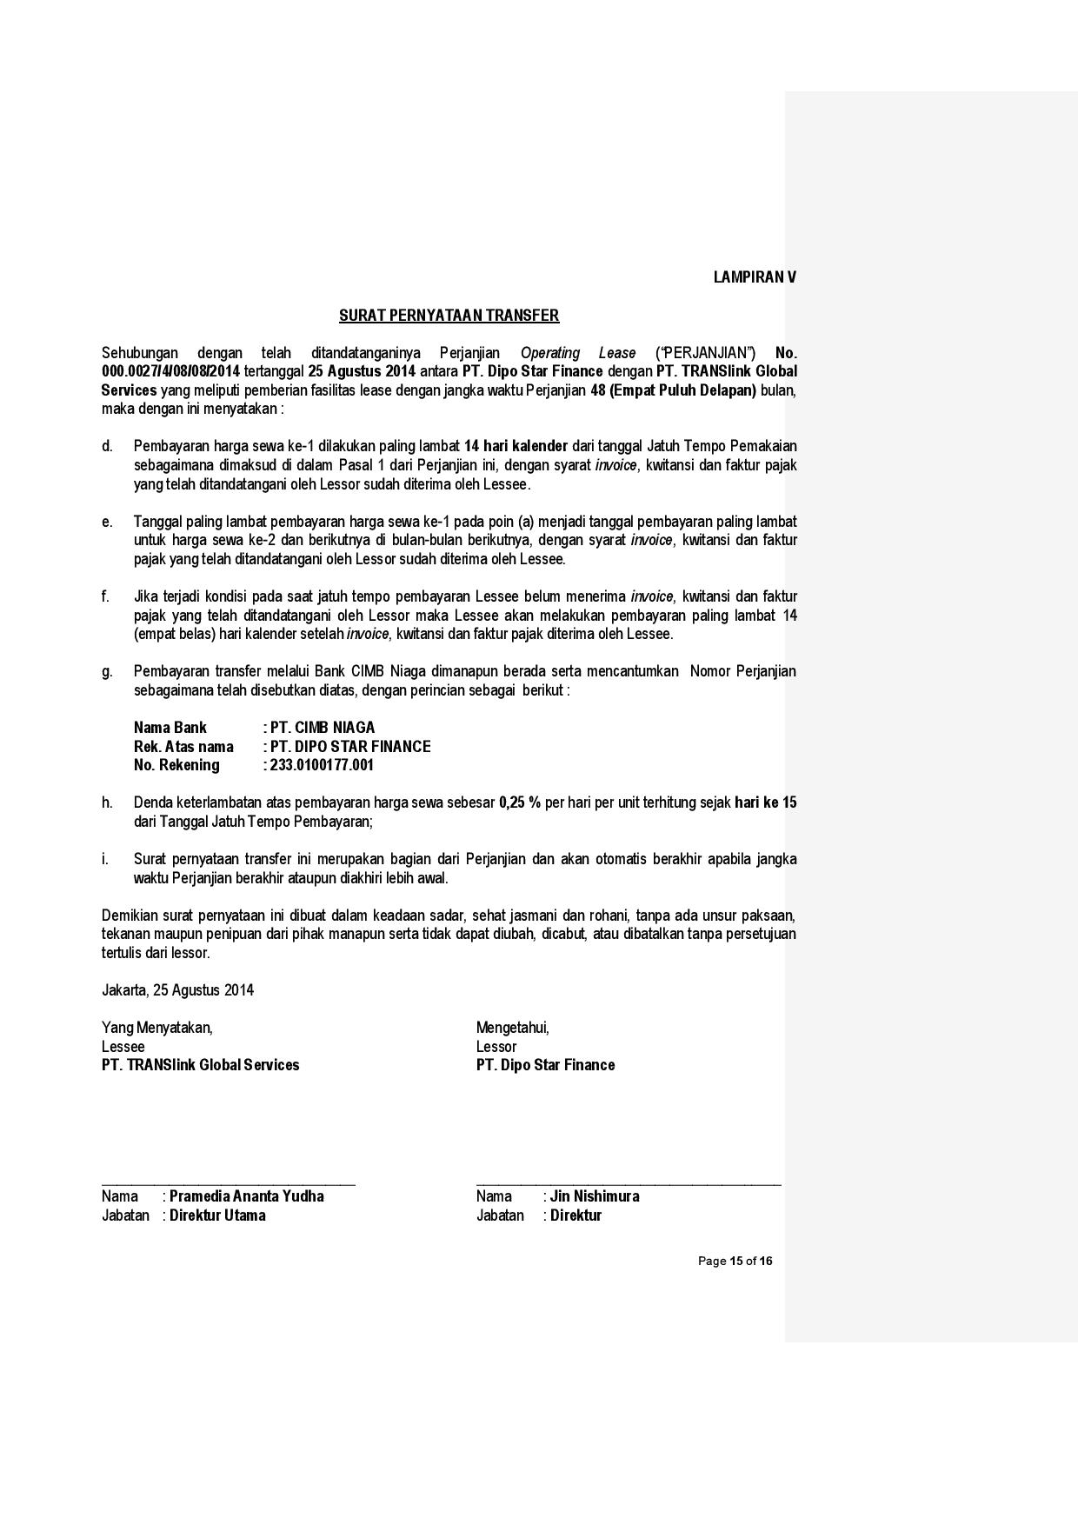**

6

5

4

3

2

1

b

a

c

d

10

9

8

7

28

27

26

25

24

21, 22 , 33

20

19

18

17

16

15

14

13

12

11

29

36, 37

35

34

33

31

32

30

43

*\*) the print out document above is the template for OPL Agreement with CSD Maintenance*

44

42

41

40

39

38

1. **Pasal 4** **poin 5** This point only exist when OPL Agreement Maintenance Type :CSD

(OPLAgreement.MaintenanceType)

1. **Pasal 7** For OPL Agreement wih Maintenance type : Full Maintenance

(OPLAgreement.MaintenanceType)

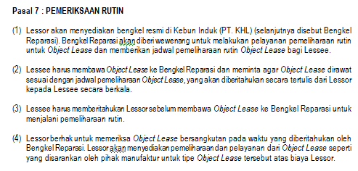

**Pasal 7** For OPL Agreement with Maintenance Type : Non Maintenance

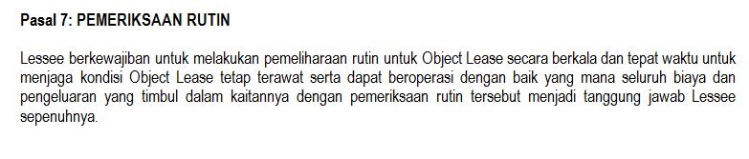

1. **Pasal 8** For OPL Agreement wih Maintenance type : Full Maintenance

(OPLAgreement.MaintenanceType)

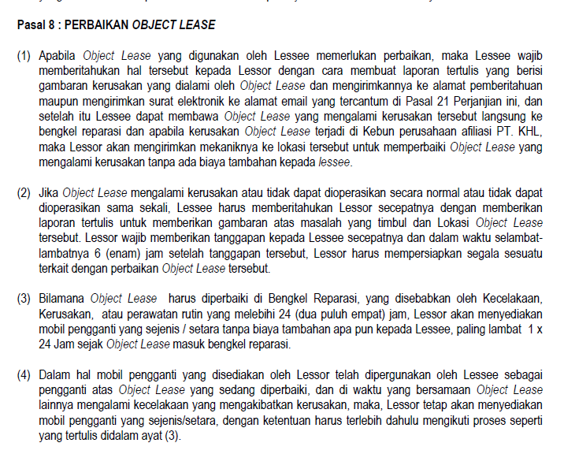

e

**Pasal 8** For OPL Agreement wih Maintenance type : Non Maintenance (OPLAgreement.MaintenanceType)

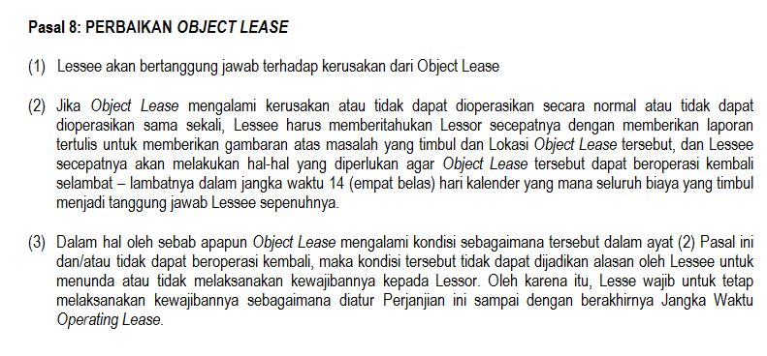

1. **Pasal 11** This only exist when OPLAgreement include Insurance(OPLAgreement.IsInsurance = 1)
2. **Pasal 8 poin 5 & 6** This point only exist when OPL Agreement include Replacement car (OPLAgreement.ReplacementUnit = 1)
   1. Entity Diagram Structure

*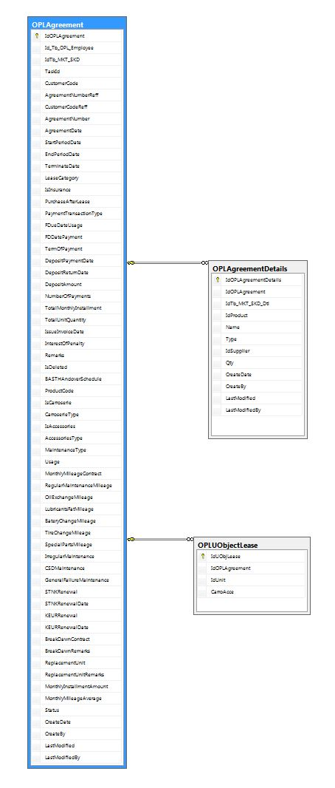*

**APPENDIX**

Configuration Access for OPL Agreement functions:

|  |  |  |  |  |  |  |  |
| --- | --- | --- | --- | --- | --- | --- | --- |
| **User** | **Branch** | **Functions** | | | | | |
| **Display List** | **Create** | **Edit** | **View** | **Print Form** | **Print Report** |
| Marketing Officer | One | V | V | V | V | V | V |
| Area |  |  |  |  |  |  |
| All |  |  |  |  |  |  |
| Head of Branch | One | V |  |  | V | V | V |
| Area |  |  |  |  |  |  |
| All |  |  |  |  |  |  |
| Head of Department | One |  |  |  |  |  |  |
| Area |  |  |  |  |  |  |
| All | V |  |  | V | V | V |
| Regional Manager | One |  |  |  |  |  |  |
| Area | V |  |  | V | V | V |
| All |  |  |  |  |  |  |
| Advisor | One |  |  |  |  |  |  |
| Area |  |  |  |  |  |  |
| All | V |  |  | V | V | V |
| Director | One |  |  |  |  |  |  |
| Area |  |  |  |  |  |  |
| All | V |  |  | V | V | V |
| President Director | One |  |  |  |  |  |  |
| Area |  |  |  |  |  |  |
| All | V |  |  | V | V | V |
| Shareholder's Meeting | One |  |  |  |  |  |  |
| Area |  |  |  |  |  |  |
| All | V |  |  | V | V | V |
|  |  |  |  |  |  |  |  |
| **Legend:** |  |  |  |  |  |  |  |
| V = Have the access |  |  |  |  |  |  |  |